Scaffolding at Grade II listed Wotton Town Hall

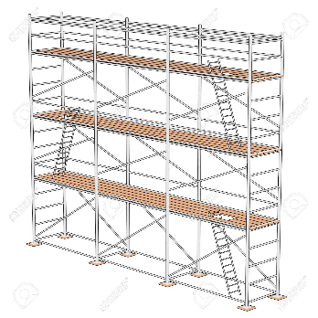
Wotton-under-Edge Town Council has instructed scaffolders to erect scaffolding around the frontage of Wotton Town Hall from early December for a period of 36 weeks. The gable woodwork on the front western elevations is in need of serious repair. This became evident when a wooden finial at the southern end dislodged during a storm in March 2020. The Council commissioned David James & Partners to undertake a condition survey which highlighted the works needed to repair this iconic structure in Market St; works totaling £100,000 are needed. Laser scan drawings have been sourced to feed into the works specification process for tender. The Council will hopefully shortly appoint a structural engineer and a contracts administrator to identify and manage contractors to undertake these works.
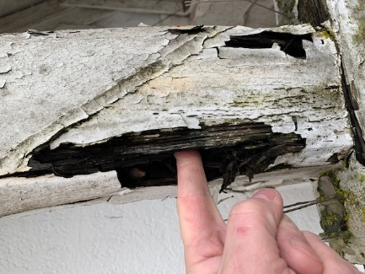
Survey costs of £2000 were met by reserves, scans and some scaffolding were met by a Glos CC grant of £5000. Further funding is needed. A grant to Historic England for £25,000 has been refused twice, and the alternatives are to use all reserves and also take out a public works loan and raise the Precept (i.e. the public paying via taxes).
If anyone can assist in any way or offer help, please do get in touch.
clerk@wotton-under-edge.com
