*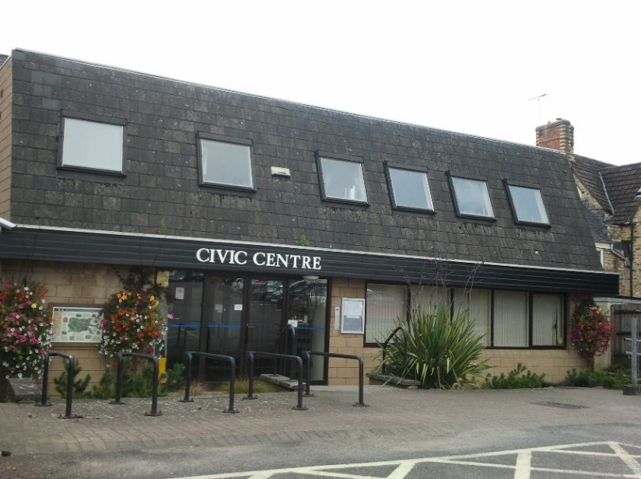**** Wotton-under-Edge Town Council***

 **STAFF ORGANISATION CHART**

**Town Clerk & RFO**

**Vacant from Jan 21**

**Buildings Manager - Phil Wilson**

**Caretaker - Andrew Burns**

**Deputy Town Clerk**

**Yasmin Milsom**

**Administrator - Diana Hyam**

**Assistant Clerk – Karen Wilson**

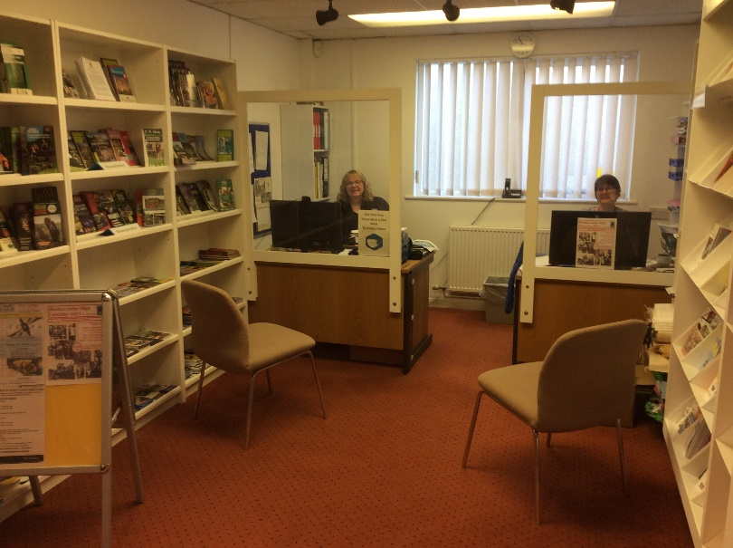

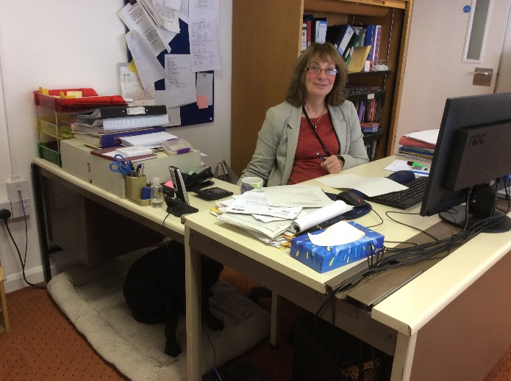



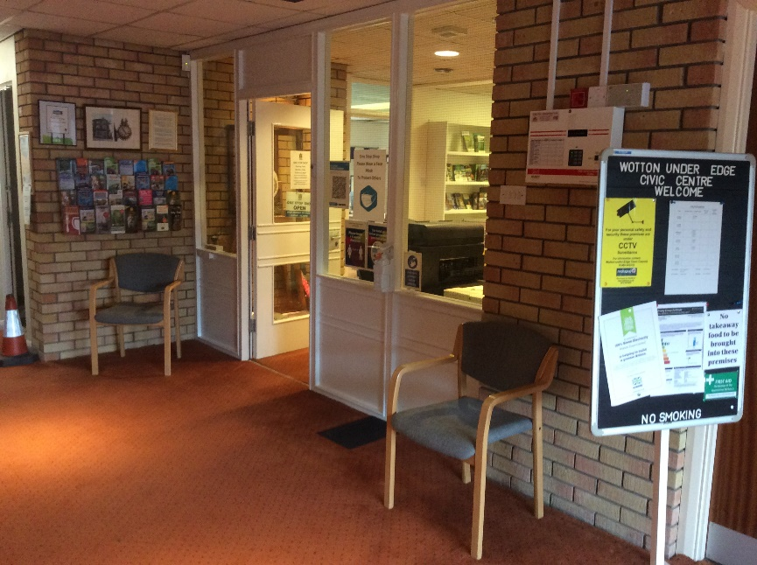

*As at October 2020. Also employed are cleaners. Most grass cutting/border*

*maintenance etc is contracted out every three years.*