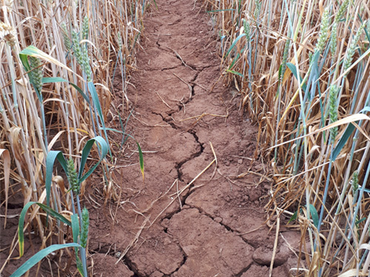

Wotton-under-Edge Town Council

Adverse Weather Policy

Reviewed Jan 20, next Review Jan 22

Introduction
This Policy outlines what work is carried out by which authority and the expectations therefrom. Access to key community facilities can be greatly reduced by the snow and ice, flood water or gale debris on roads and footways within the town. During periods of severe weather, many residents can be prevented from leaving their homes to access local facilities which affects the quality of life of many residents and also affects businesses providing services within the town. The Town Council and local community accept that Gloucestershire County Council only has responsibility for clearing main roads and therefore accept that provision of a higher level of service will require self-help and community interaction. The Town Council appoints two snow wardens each year whose duties are at the end of this document.

Summary
In a situation where gritting of surfaces is required due to inclement weather, the following is the order of priority:
- County Council grits the main arterial routes into and through the town as highlighted in colour yellow on the map below. This work is undertaken by a local snowplough operator with a snowplough.
- The Buildings Manager (whilst waiting for the above to be carried out) clears as much snow as possible and grits the pedestrian entrances to the Civic Centre, the adjacent car park, the entrance in front of the Town Hall, and the almshouses footways.
- When the snowplough operator has finished Glos CC duties, it is expected that the Buildings Manager will join him on the snowplough and undertake clearance on the Wotton roads coloured green on the map below, gritting them also. Please note that the roads highlighted pink cannot be accessed with the snowplough and are thus not cleared.
- If bad weather happens on a weekend, the above will be undertaken if the Buildings Manager is available, and overtime is paid.
- The Town Council has only limited resources undertaking the above, and therefore it must be noted that the above is always subject to situation and resource availability.
- The shopping street is not cleared by the Town Council or Glos CC and traders are expected to clear in front of their own properties. No other footways are cleared in Wotton by the Town Council. A leaflet is available from Glos CC outlining individual responsibilities relating to clearance of footways. The Town Council will endeavour to clear some footways where there are particular problems and when time and available effort allows, although this cannot be guaranteed.

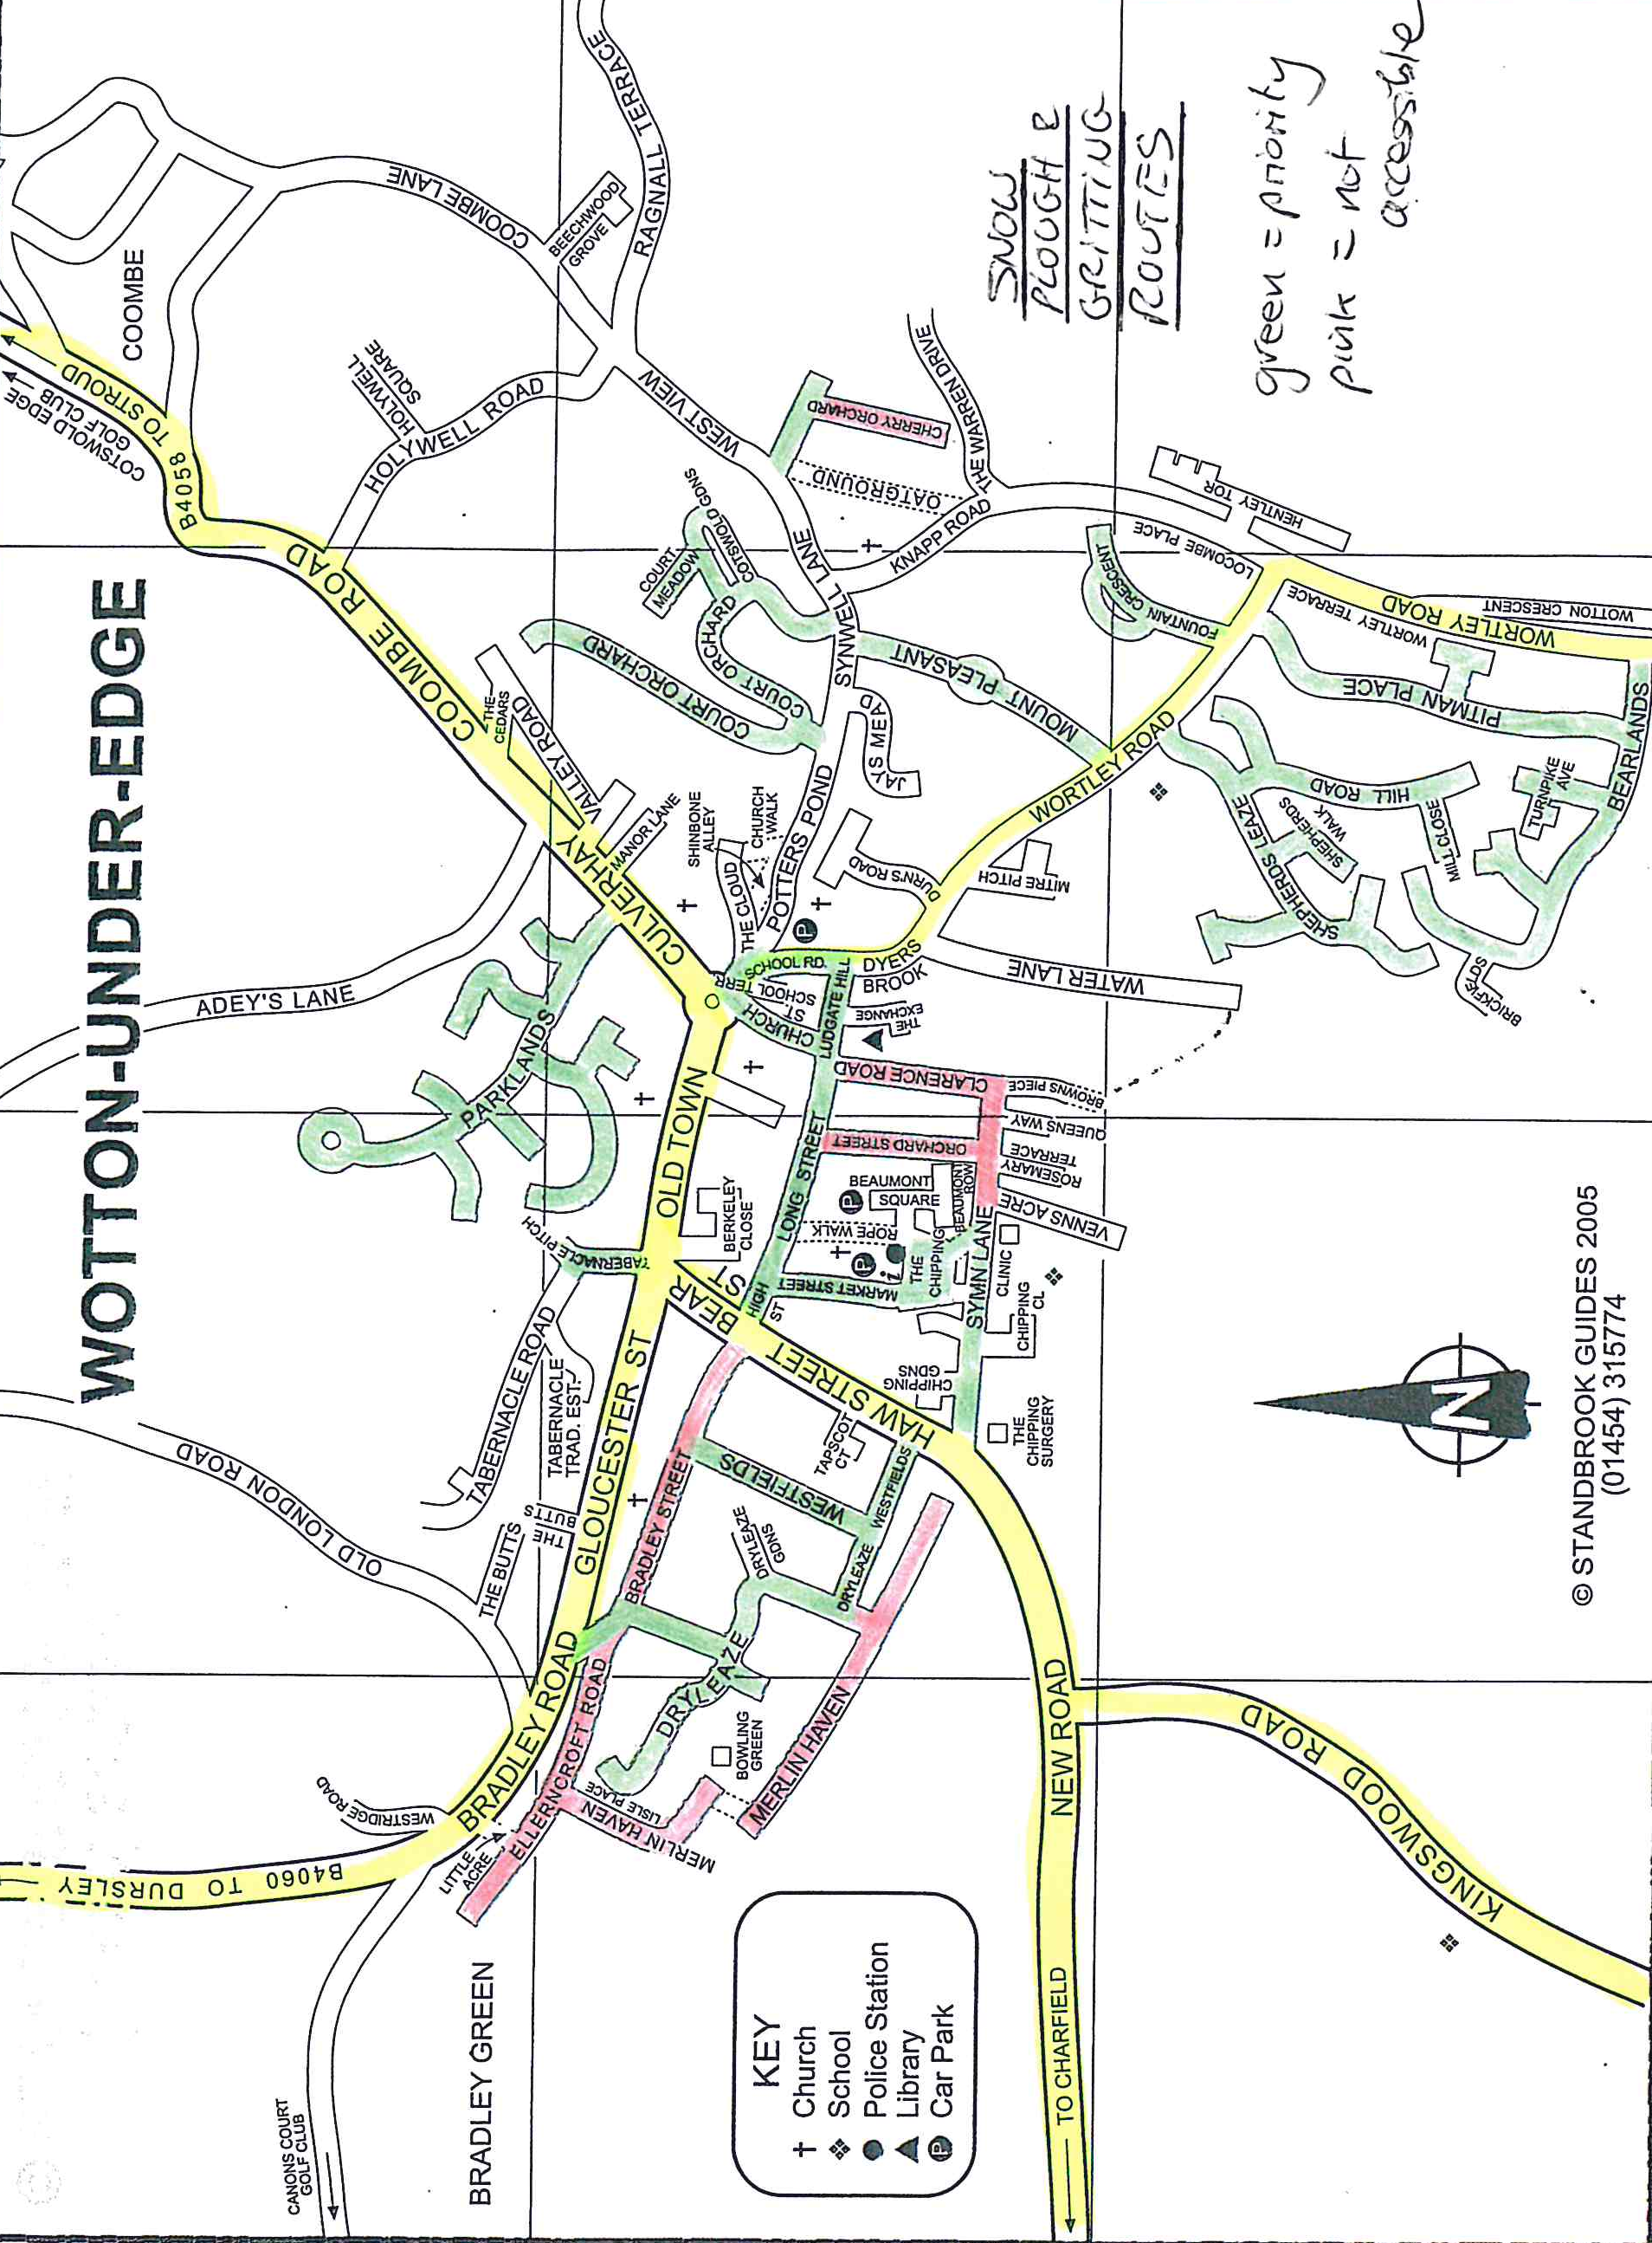

Grit Bins
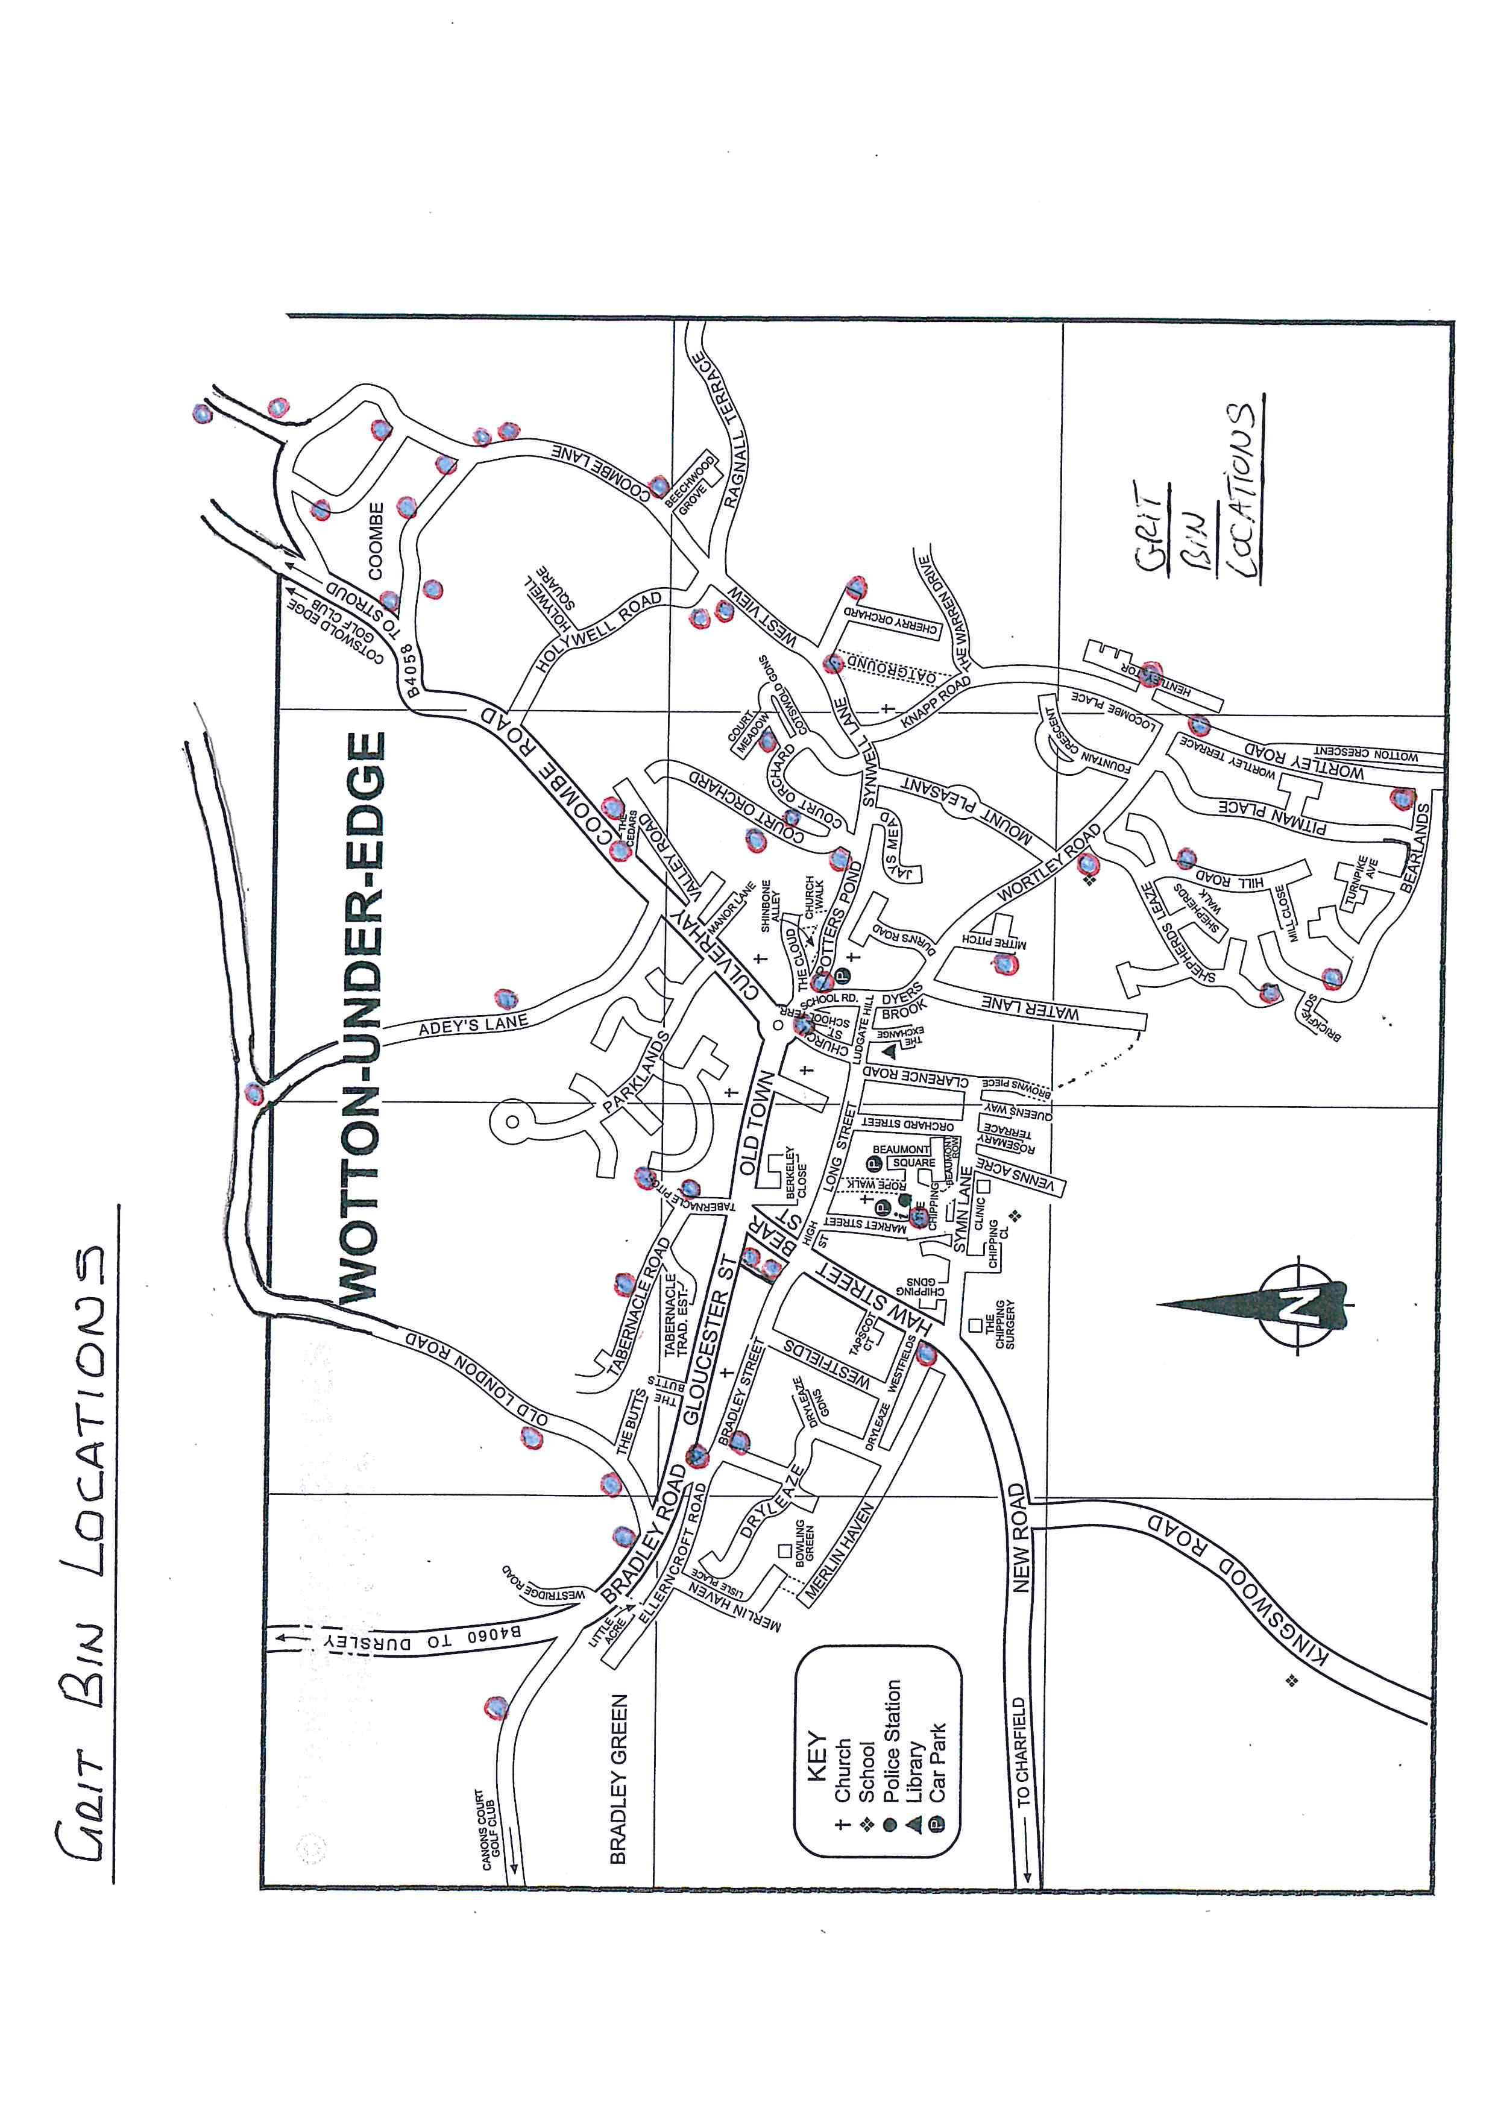
Grit bins have in the past been provided by both Glos CC Highways and also the Town Council. The locations of these is on the map below. The grit bins are filled by Glos CC Highways at the beginning of the season and only filled thereafter if possible. The Town Council has a small number of bags from which it can replenish stock. A small amount of emergency grit reserves is held at Bradley Farm on the Town Council’s behalf as a goodwill gesture.

Equipment/Materials
Glos CC has provided a hand spreader to Town Councils to assist in spreading salt on some footway areas and a small supply of bagged salt.

HAZARD IDENTIFICATION AND RISK ASSESSMENT for Snow Wardens
Ref | Hazard | P | S | R | Response/Control Measure | P | S | R | *Output
 | Exposure to the elements – severe cold or hypothermia | 2 | 3 | 6 | Adequate PPE including warm clothing to be worn.  Fully charged mobile phone to be carried. | 1 | 2 | 2
 | Lone working – risk of injury, risk of attack by member of public | 3 | 3 | 9 | Person to ensure that someone knows of his or her location and approximate time of return.  Person is fit to lone work.  Work activity/area must be safe to be undertaken by one person.  Lone worker is provided with means of communication to summon assistance in an emergency. | 2 | 3 | 6
 | Maintenance of winter maintenance equipment – risk of malfunction of equipment | 3 | 2 | 6 | All equipment used for winter maintenance to be subject to regular maintenance.  Prior to leaving storage, operator to undertake visual check of all functions associated with equipment. | 2 | 2 | 4
 | Slips, trips and falls – during snow clearance, gritting footways or filling grit bins – injury to operative or other members of the public | 3 | 3 | 9 | Operative awareness.  Appropriate footwear to be worn by operative carrying out work.  Awareness of volume and location of pedestrian activity and extent of footway areas being occupied. | 1 | 3 | 3
 | Manual handling – risk of injury during movement of equipment or materials | 3 | 3 | 9 | Operative awareness.  Person is fit to undertake activities; work activity/area must be safe to be undertaken by one person or should be adjusted accordingly.  Appropriate equipment should be used for moving or handling materials. | 1 | 3 | 3
 | Traffic – risk of injury from passing traffic whilst carrying out activities | 2 | 4 | 8 | Operative awareness.  Activities to be limited to pedestrian areas only. (snow wardens and volunteers will not clear road!) | 1 | 4 | 4

Health & Safety
P = probability (1 to 5) S = severity (1 to 5) R = risk = probability x severity. A risk assessment above seeks to cover the risks and control measures associated with staffing activities. Salt usage spread is recommended @40g per m²

Snow Code from DirectGov website
www.direct.gov.uk/en/Nl1/Newsroom/DG_191868

Clearing snow and ice from pavements yourself
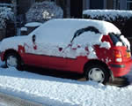
There's no law stopping you from clearing snow and ice on the pavement outside your home or from public spaces. It's unlikely you'll be sued or held legally responsible for any injuries on the path if you have cleared it carefully. Follow the snow code when clearing snow and ice safely.

The snow code - tips on clearing snow and ice from pavements or public spaces

Prevent slips
Pay extra attention to clear snow and ice from steps and steep pathways - you might need to use more salt on these areas.
If you clear snow and ice yourself, be careful - don’t make the pathways more dangerous by causing them to refreeze. But don’t be put off clearing paths because you’re afraid someone will get injured.
Remember, people walking on snow and ice have responsibility to be careful themselves. Follow the advice below to make sure you clear the pathway safely and effectively.

Clear the snow or ice early in the day
It’s easier to move fresh, loose snow rather than hard snow that has packed together from people walking on it. So if possible, start removing the snow and ice in the morning. If you remove the top layer of snow in the morning, any sunshine during the day will help melt any ice beneath. You can then cover the path with salt before nightfall to stop it refreezing overnight.

Use salt or sand - not water
If you use water to melt the snow, it may refreeze and turn to black ice. Black ice increases the risk of injuries as it is invisible and very slippery. You can prevent black ice by spreading some salt on the area you have cleared. You can use ordinary table or dishwasher salt - a tablespoon for each square metre you clear should work. Don’t use the salt found in salting bins - this will be needed to keep the roads clear.
Be careful not to spread salt on plants or grass as it may cause them damage.
If you don’t have enough salt, you can also use sand or ash. These won’t stop the path icing over as well as salt, but will provide good grip under foot.

Take care where you move the snow
When you’re shovelling snow, take care where you put it so it doesn’t block people’s paths or drains. Make sure you make a path down the middle of the area to be cleared first, so you have a clear surface to walk on. Then shovel the snow from the centre of the path to the sides.

Offer to clear your neighbours’ paths
If your neighbour will have difficulty getting in and out of their home, offer to clear snow and ice around their property as well. Check that any elderly or disabled neighbours are alright in the cold weather. If you’re worried about them, contact your local council.

Snow Wardens - Amended Duties & Responsibilities ref: Wotton Town Council
- Snow Wardens are volunteers appointed by the Town Council. Full contact details will be held by the Town Clerk and will be made available as necessary to other bodies such as the County Council.
- During periods of severe winter weather, information regarding local snow conditions should be provided to Town Council staff by Snow Wardens - ideally before midday. Town Council staff should then contact the County Council Area Office. This will allow the Area Highways Manager to make a comprehensive review of weather and road conditions across each area of the county before the West Area Highways Manager considers countywide conditions. The information provided should include:
- The extent and estimated depth of snow including degree and direction of snow drifts
- Location of blocked roads
- Progress already made in clearing blocked roads and snow drifts
- Locations that are causing local communities the greatest problems
- The primary objective of Snow Wardens is to facilitate arrangements for the clearance of blockages on local roads whilst GH’s resources are prioritised in maintaining the strategic road network as priority. Normally, such assistance will involve reporting local problems to Town Council staff who will then liaise with the Area Office.
- The Area Office may request Town Council staff to bring into operation any available local snow ploughs as necessary to clear main highways. In the event of extreme conditions, Town Council staff may initiate such operations as are appropriate to clear local roads and to overcome emergency situations. Snow Wardens should report emergency situations to Town Council staff at the earliest opportunity. In emergency situations, Town Council staff will keep the Area Office informed.
- Snow Wardens may also assist with footway clearance activities in the Town and with local road clearance activities where such action can be undertaken without danger to the individual. Local self-help plays an important role in helping to deal with snowfall particularly when GH’s resources are prioritised in maintaining the strategic road network. Self help arranged by the Snow Wardens should be carried out in accordance with the DFT guidance document; “Snow Code”.
- The aim of the snow warden is to foster and encourage local self-help from the voluntary spirit that is so apparent in emergencies to organise and direct local resources to best effect. Subject to staff availability, the Town Council website and other social media will be used to notify the community about problem situations where volunteer assistance is required.
- Prior to and during severe winter weather conditions wardens should establish and maintain contact with Town Council staff who will have the contact details of local Snow Plough Operators and neighbouring Parishes. Snow Wardens should familiarise themselves with the geography and road system in the parish.
- The Snow Warden should pass on to Town Council staff any advance adverse weather information received from the Area Team during the winter season. If appropriate, Town Council staff will pass this information on to local Snow Plough Operators where action to clear local roads is anticipated.
- .If a severe weather warning has been issued and a Snow Warden is unable to operate temporarily during the period November to March (e.g. because of sickness or absence from home) then Town Council staff and the other Snow Wardens should be informed.
- Where Parish Councils have accepted a locally controlled stockpile of salt from Area Team, the Snow Warden should co-ordinate the appropriate action of the volunteers by either salt spreading as previously agreed between the Town Council/Area Team and/or the replenishment of salt in existing grit bins.
- Where parish councils have not accepted a locally controlled stockpile of salt from the Area Team the Snow Warden should monitor existing grit bins and report to Town Council staff the need for refilling or any misuse of the salt stock.
- Town Council staff will keep a record of all authorised local snow plough activity.
- Town Council staff will supply and keep up to date a list (or plan) of all grit bins located within the parish boundaries.
- It is intended that the Snow Warden will also operate in the event of other severe weather conditions, such as widespread flooding and gale damage, where traffic routes are disrupted. Emergency response activities during these conditions will be managed by GH’s Area Highways Managers. Snow Wardens may be called upon to provide information on local conditions including blocked roads and recommended alternative routes. Normally, this information will be passed to Town Council staff who will contact the Area Office.
- Requests for assistance by Snow Wardens outside of the normal interests of GCC as a highway authority should be made directly to the police.

