Minutes of Wotton-under-Edge Town Council Meeting

Monday 17TH May 2021 held in the Civic Centre

Present: Cllrs R Claydon, P Barton, J Cordwell, R Hale, T Luker, D Thomas, M Tucker, J Turner, L Taylor

In attendance: A Durn (Town Clerk), K Wilson (Assistant Clerk); District Cllrs C Braun, K Tucker; County Cllr L Cohen, plus 5 Members of the Public

T.6243 To elect the Town Mayor and Chair of the Town Council and receive the Declaration of Acceptance of office.
It was RESOLVED to re-elect Cllr R Claydon as Chairman and Mayor. Signed Declaration of Acceptance of Office was received.

T.6244 To elect the Deputy Town Mayor and Vice Chair of the Town Council and receive the Declaration of Acceptance of office.
It was RESOLVED to elect Cllr M Tucker as Vice Chairman and Deputy Mayor. Signed Declaration of Acceptance of Office was received.

T.6245 To welcome new Councillors and receive the Declaration of Acceptance of office.
The newly elected Chair welcomed back returning Councillors and gave a special welcome to new Councillor L Taylor. Signed Declarations of Acceptance of Office were received.

T.6246 To received apologies for absence
District Cllr K Tucker gave District Cllr G James’s apologies.

T.6247 To consider and approve candidates for co-option to the Council and receive the Declarations of Acceptance of office.
Applications from four members of the public had previously been received and circulated. There were no further applications received at the meeting. The applications had been reviewed and there were no questions. There were four Councillor vacancies on the Town Council.
It was RESOLVED to co-opt all four candidates in to the four vacancies on the council. Declarations of Acceptance of Office were signed and received. The co-opted members were invited to join the meeting and all Councillors introduced themselves.

T.6248 To receive reports from County and District Councillors.
The District Councillors circulated the following report prior to the meeting. The following items were highlighted – the new draft Local Plan is going to final consultation. District Cllr Braun highlighted the Private Members Bill currently going through Parliament in respect of the Carbon Neutral Strategy.
County Councillor report – Cllr Cohen introduced herself and mentioned she was looking forward to working for the town.
The Chair welcomed County Councillor L Cohen to the meeting and that the Town Council was looking forward to working with her.

Stroud District Councillors’ Report – May 2021
Report of meetings during April

All Stroud District Council and Committee papers can be found here:
https://www.stroud.gov.uk/council-and-democracy/meetings

Results of the Local Elections – 6 May
The results of the elections to Stroud District Council (SDC) were as follows (showing change from the previous election results in 2016):
Lib Dem: 3 councillors (+1), Green: 13 councillors (+5), Labour: 15 councillors (-3), Conservative: 20 councillors (including one independent Conservative councillor) (-3). Since the results indicate No Overall Control for one party, the parties are in discussions on how to work together.
Nominations will be submitted for Committee roles and membership for the AGM meeting on 20 May
(see agenda) .

Environment Committee – 20 April 2021
Committee papers can be found here.
The Committee discussed the following issues:
- Tree Strategy – the strategy links to the SDC 2030 Strategy in particular the commitment (NE11) to support the countywide approach and advocate continued efforts for nature recovery through tree planting in collaboration with the Local Nature Partnership for an efficient and expert led approach to trees in Stroud District.
- Recycling – Developments for the Future – discussion of a paper outlining potential improvements, which would better insulate the District Council from the fluctuations of markets in the sale of recyclates.
- Pre-Submission District Local Plan – the main item for discussion – to agree the new strategic plan for the whole of the District. This is in accordance with Regulations 19 and 20 of the Town and Country Planning (Local Planning) (England) Regulations 2012. See Council meeting below for further notes.
There were also Member Reports from the Planning Review Panel, Stroud Regeneration Committee, and a Performance Monitoring report.

Full Council meeting – 29 April 2021
The Council papers can be found here.
Stroud District – New Local Plan
A long meeting (over 4 hours) which focused on the Pre-Submission District Local Plan. Residents from Berkeley and Sharpness Residents Association and the Wisloe Action Group attended and asked questions during the Public Question Time in relation to the proposal for these communities to become strategic development sites.
Councillor Simon Pickering presented the report and thanked all who had worked so hard on developing the draft Local Plan.
The government expectation for Local Planning Authorities is to require an update to the Local Plan every five years. An update to the District’s current adopted Local Plan is now due as it is over five years old and the housing requirements it set out are no longer up to date. Any further delay, additional to the recent delays already experienced due to the pandemic and possible changes in government policy, would increase the risk of the occurrence of “planning by appeal”.
A series of measures to implement the Carbon Neutral 2030 Strategy are embedded throughout the plan: net carbon zero construction standards, carbon zero heating systems, identification of suitable areas for renewable energy, at least 10% new biodiversity gain, multifunctional green space and tree-planting, reuse and regeneration of brownfield land, planning for exemplar carbon neutral settlements, support for active travel and walking and support for the reopening of two new rail stations at Stonehouse and Sharpness.
Central government sets out the minimum number of new houses to be provided in the district, which has been raised from a minimum of 456 to 630 homes per annum to be built, largely by private developers, which is an increase of 38%.
There is therefore a need for some more new housing, particularly to support longer life expectancy, improvements in the status of women and the need for affordable houses for younger adults, three of the key drivers in the need for more housing. A buffer is required by the government and so Planning Strategy Officers have advised an overall housing supply of 14,935 homes. Although covering just under 187 square miles, approximately half the district is in the Area of Outstanding Natural Beauty, and a considerable area is now at risk of flooding, therefore only roughly one third of the district remains available for allocation.
Reducing the need to travel by private car, the single largest source of greenhouse emissions in the district, has been a primary factor in the development strategy towards delivering the Carbon Neutral 2030 Strategy. Extensive public consultation and work have been carried out during the Local Plan Review.
The main objectives of the strategy for the new Local Plan set out to:
• concentrate housing growth at population centres with best access to services and facilities
• develop new settlements where there is potential to create more sustainable communities
• regenerate the canal corridor through the Stroud Valleys, and Berkeley and Sharpness
• maximise the use of previously developed land
• provide strategic employments accessible within the M5/A38 corridor
• support the development and social sustainability of small towns and villages
It is essential that a sound Local Plan can stand up to scrutiny and that decisions on the choices of sites are transparent, logical and underpinned by evidence (particularly following the experience of the South Gloucestershire / West of England Joint Spatial Plan, which was rejected by planning inspectors). The assessment of potential sites to meet the plan requirements has been rigorously tested and it was noted that the Council can only consider sites supported by landowners as they must be deliverable.
Gloucester City Council has identified a shortfall of 6,000 dwellings to meet future housing needs and has asked for help from neighbouring authorities with fulfilling this. It is both a national policy requirement and legal duty that Stroud District Council work co-operatively to accommodate unmet need in the most sustainable places. Following a joint assessment, a site at Whaddon has been identified for up to 3,000 dwellings. Cllr Pickering underlined that the proposal at this stage was not to allocate this site, but to safeguard it. The site would only be allocated subject to Gloucester City wanting the site to be allocated and providing up to date evidence of need at the Local Plan Examination
Conservative Councillors proposed two amendments which would have a) removed Wisloe (PS37) and inserted Moreton Valence (PGP2), and b) removed PS34 (Sharpness Docks) and PS36 (Sharpness new settlement) and replaced them with Moreton Valence and Whitminster. Both amendments failed. The Draft Local Plan was approved for publication with 26 votes for, 7 against and 8 abstentions. The Pre-Submission Draft Plan can be found here.

Visual overview of the development strategy
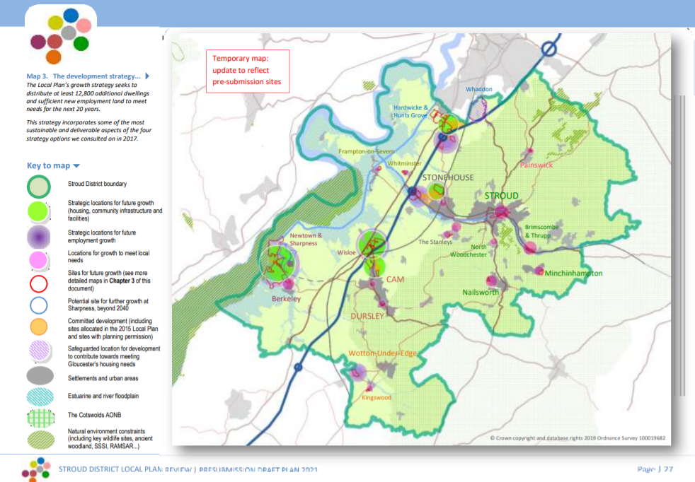

Strategic Development Sites
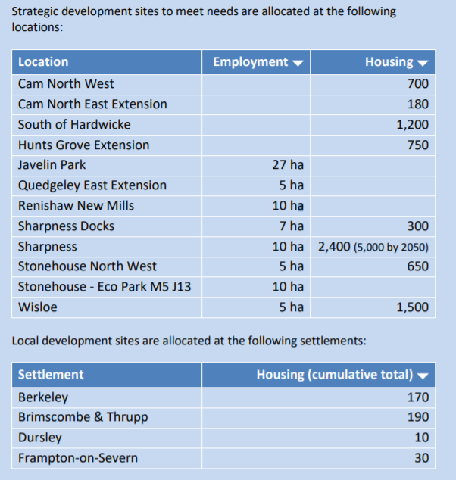

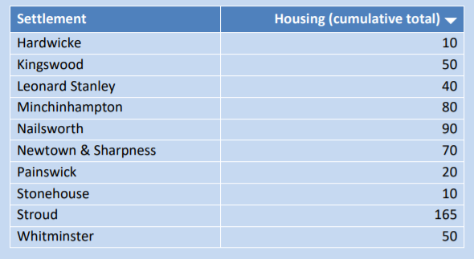

Now that the Draft Local Plan has been approved, it will be subject to six weeks of formal public consultation in accordance with legal regulations, commencing at the end of May/early June 2021.
The Draft Local Plan, together with consultation representations received and supporting documents, will then be submitted to the Planning Inspectorate, anticipated by September 2021. Depending upon progress with the examination, it is hoped that receipt of a favourable Inspector’s Report will allow the Council to adopt the new Local Plan by the end of next year 2022.

Ubico Shareholder Decision
Councillors agreed to support Gloucester City Council joining the Ubico partnership (which provides collection of waste and recyclates in the District). The SDC Chief Executive has a role as the Council’s Ubico Shareholder.

Motion: Climate and Ecological Emergency Bill
Councillors voted to support a motion about this Bill. The motion noted that humans have already caused irreversible climate change, the impacts of which are being felt in the UK and around the world. Global temperatures have increased by 1 degree Celsius from pre-industrial levels. Atmospheric CO2 levels are above 400 parts per million (ppm) and continue to rise. This far exceeds the 350 ppm deemed to be a safe level for humanity. Without more significant and sustained action, the world is set to exceed the Paris Agreement’s 1.5°C limit between 2030 and 2040.
Therefore, the current UK target of net zero by 2050 is not satisfactory. It is too little too late. The increase in harm caused by a rise of 2°C rather than 1.5°C is significant. This is described by the Intergovernmental Panel on Climate Change’s Special Report on Global Warming of 1.5°C published in October 2018.
According to the IPCC, limiting heating to 1.5°C may still be possible with ambitious action from national and sub-national authorities, civil society, the private sector and local communities. The costs of failing to address this crisis will far outstrip the investments required to prevent it. Investing now will bring many benefits in the form of good jobs, breathable cities and thriving communities.
The Council noted that
- This council has declared a climate and ecological emergency;
- There is a Bill before Parliament—the Climate and Ecological Emergency Bill (published as the “Climate and Ecology Bill”)—according to which the Government must develop an emergency strategy that:
  - requires that the UK plays its fair and proper role in reducing greenhouse gas emissions consistent with limiting global temperature increase to 1.5 degrees C above pre-industrial temperatures;
  - ensures that all the UK’s consumption emissions are accounted for;
  - includes emissions from aviation and shipping;
  - protects and restores biodiverse habitats along overseas supply chains;
  - restores and regenerates the UK’s depleted soils, wildlife habitats and species populations to healthy and robust states, maximising their capacity to absorb CO2 and their resistance to climate heating;
  - sets up an independent Citizens’ Assembly, representative of the UK’s population, to engage with Parliament and Government and help develop the emergency strategy.
The Council therefore resolved to:
1. Support the Climate and Ecological Emergency Bill
2. Inform the local media of this decision;
3. Write to local MPs, asking them to support or thanking them for supporting the Bill; and
4. Write to the CEE Bill Alliance, the organisers of the campaign for the Bill, expressing its support (campaign@ceebill.uk).

Housing Committee – 8 April
The Agenda and papers can be found here
The Committee discussed the following papers – with action plans for each to follow at the next Housing Committee meeting.
- Update of the Tenant Led Service Standards
To agree the updates made to the Tenant Led Service Standards.
- Cleaner Estates Strategy 2021-24
To agree that the strategy is fit for purpose and that a detailed action plan is to be presented to Housing Committee in June 2021.
- Updated Tenant Services Anti-Social Behaviour (ASB) Policy
To note the updates to the Tenant Services Anti-Social Behaviour Policy.

Audit & Standards Committee - 27 April
The Committee discussed the following:
- Audit and Standards Committee Annual Report 2020/21
The Annual Report summarises the activities of the Committee during 2020/21 and sets out its plans for the next twelve months. This report provides an independent assurance that the Council has in place adequate and effective governance, risk management and internal control frameworks; Internal and External Audit functions; and financial reporting arrangements.
- Internal Audit Activity Progress Report 2020/21
- Draft Internal Audit Plan 2021/22
- Creditors Limited Assurance Update
- 3rd Quarter Treasury Management Activity Report 2020/21
- Counter Fraud Unit Report and Regulation Of Investigatory Powers Act (RIPA) 2000 / Investigatory Powers Act (IPA) 2016 Report
The Committee’s annual report will be further considered at the Council meeting on 20 May.
The Chair thanked the District Councillors for their report.

T.6249 To receive any Declarations of Interest and Dispensations.
The Chair submitted a request for a Declaration of Interest and Dispensation for the Recreational Trust to allow members to vote on an item on the Recreational Trust later in the agenda.
It was RESOLVED to approve the dispensation to allow members to vote on the item on the Recreational Trust.

County Cllr Cohen and District Cllr Taylor left the meeting

T.6250 Election of Membership to Committees and Partnerships:

Planning Committee

It was RESOLVED to elect all Town Councillors to be members of the Planning Committee.

T.6251 Appointment of representatives to organisation.
It was RESOLVED to continue with the 2020/21 Town Councillor representatives and review at the June 2021 Town Council meeting.

T.6252 Banking
It was RESOLVED to approve the following signatories for the bank authorisation of the Town Council and Town Trust accounts:
Cllrs R Claydon, J Cordwell, T Luker, N Pinnegar and M Tucker.

T.6253 The General Power of Competence (GPC)
The Clerk explained the General Power of Competence, its requirements and what happens in its absence.
It was RESOLVED that the requirements of the General Power of Competence are currently not met.

T.6254 Public Forum
A member of the public spoke about their wish to improve Wotton for residents and visitors and for Wotton to be environmentally sustainable. The waterways at Marchesi Walk, Brown’s Piece, and Holywell were highlighted, and the Town Council was asked to keep the waterways clean and maintained. Concerns were raised about the amount of traffic and the impact of pollution in the town. A request was made to engage more young people to take an active interest in the town, as well the Town Council to take positive action to encourage tourism and to make the High Street a more pleasurable and enjoyable experience to visit and shop.

The Chair thanked the member of the public for her comments and submissions and explained the actions the Council was already taking regarding protecting the environment. He said her comments were noted and would be reviewed.

One member of the public left the meeting

T.6255 Minutes of the Extraordinary Council Meeting of 26th April 2021
It was RESOLVED to approve the Minutes of the Town Council meeting on 26th April 2021 as a true and fair record.

T.6256 Chairman’s Announcements
The Chairman reported he had attended one meeting for the Recreational Trust. There were no questions.

T.6257 Accounts

To approve subscription to the Institute of Cemetery and Crematoria Management at a cost of £95
It was RESOLVED to approve the annual subscription of the Institute of Cemetery and Crematoria Management.

To approve cemetery memorial training course for Buildings and Facilities team at a cost of £270 for two people.
It was RESOLVED to approve the training fees for the cemetery memorial course.

To approve the Buildings and Facilities team to attend a play area routine inspection course at a cost of £500 for two people.
It was RESOLVED to approve to delegate the arrangements for a play area inspection course to the Clerk.

To consider and approve contractor for automatic doors maintenance contract.
The quotes were reviewed.
It was RESOLVED to approve the annual contract to Power-A-Door.

To approve works at Hill Road amenity area.

The quotes were reviewed.
It was RESOLVED to approve the works at a cost of £223.20

To agree to increased contracted cleaning hours due to lifting of COVID restrictions.
It was RESOLVED to delegate the increasing of contracted cleaning hours to the Clerk, as required.

To agree to purchase PPE for the Buildings and Facilities team.

The report was reviewed and discussed.
It was RESOLVED to delegate the identification and procurement of PPE to the Clerk

Budget 2021.
It was noted there was no report this month due to end of year processes.

To approve May accounts for payment.
The list of payments was previously circulated.
It was RESOLVED to approve the payments listed of £6,924.07 plus VAT where applicable.

T.6258 Play Area Inspection, Symn Lane.
The ROSPA annual inspection report and recommendations report were previously circulated. The Clerk reported that on the morning of the meeting the wooden gate had been vandalised.
It was RESOLVED to carry out the recommendations with the exceptions of two Rockers and the Rotator Bowl. The two Rockers will continue to be monitored by the Buildings and Facilities Team, who will also assess if a repair or replacement is required. The Rotator Bowl to be monitored and checked after the Buildings and Facilities Team have received training.

District Cllr Braun left the meeting

T.6259 Chipping Clubroom/Youth Centre Planters

It was RESOLVED to approve the Council Office staff to plant the planters and the Buildings and Facilities team to maintain the watering. Delegation was passed to the Clerk to purchase suitable plants, achieving value for money and in the future to look at ways of including young people in this project.

T.6260 Trees

Streamsfield
The land at Streamsfield is currently leased to the Recreational Trust, however, the Trust is discussing handing back the land to the Town Council. The neighbouring residents had raised concerns about the safety of the trees on Streamsfield that are next to their properties.

It was RESOLVED for the Town Council to take responsibility for the land from the Recreational Trust and to maintain the trees next to Public Right of Way and residential properties. It was delegated to the Clerk:

to action based on Health and Safety and value for money.

To the requirements for the transfer of the land from the Recreational Trust.

Cemetery Trees

Complaints had been received about anti-social behaviour under and behind trees in the Cemetery, and from neighbouring residents about overhanging and dead branches and trees and shrubs.

It was RESOLVED to delegate to the Clerk to action based on Health and Safety and value for money.

T.6261 Symn Lane Car Park Development.
A report had previously been circulated and was discussed. The EV chargers are predominantly for residents to charge their cars overnight. Other sites would be preferable for future faster chargers. Thanks were given to Cllr Claydon for his work on this project.
It was RESOLVED to accept the recommendations in the report and to approve the initial installation of 3 dual electric vehicle (EV) chargers, with the developer agreeing to supply the power supply cabling.

T.6262 Great British Spring Clean-up
The Clerk had previously spoken with groups who tidy Wotton and they reported that as much of the community and community groups keep the town tidy, it may not be practical to hold an event for this initiative. The Clerk has asked the town for suggestions. It was suggested Cllrs could help with the tidy up suggestions including weeding of carparks and bus stop painting.
It was RESOLVED to delegate to the Clerk with the staff and Cllr J Turner to develop a plan.

T.6263 Clerk’s Report
The report was noted with thanks. Thanks were received from neighbouring residents to the allotment regarding the removal of plants that were encroaching on their property. Thanks were given to council staff for their hard work and on social media campaigns for the town.

T.6264 Correspondence
- Receipt of a refund of £120 from the closure of the Chamber of Trade was noted.
- A requested for chatting benches with signage being funded by a resident was received. Council to consider the matter and bring a proposal to a future meeting for decision.
- A request from a member of the public to start a “voucher” scheme within the local shops was received. After some discussion it was felt this would not work within Wotton. The Clerk will respond to the individual highlighting the issues raised.
- The Air Ambulance gave thanks for a donation.

T.6265 Brief reports from Councillors
Footpaths Committee, Special Purposes Committee, Allotments Committee, Wotton Youth Partnership, Town Regeneration, Sports Foundation, Wotton Pool, Heritage Centre, and any other meetings attended.
Meetings attended as follows:
Youth Partnership – updates were given on inter-generational project, Mental Health project, Partnership planning.
Wotton Walking Festival –three-day event between June 11th to 13th 2021, many walks are already full.
Stroud Tourist Forum – ideas were exchanged on promoting Wotton and the surrounding area, integrating with other initiatives such as Visit Gloucestershire.
Allotments committee – all allotments are now let and there is currently a waiting list.

The meeting closed at 8.50pm

Signed: ……………………………………Dated: …………………………

