Wotton Cemetery
Wortley Road
Wotton-under-Edge
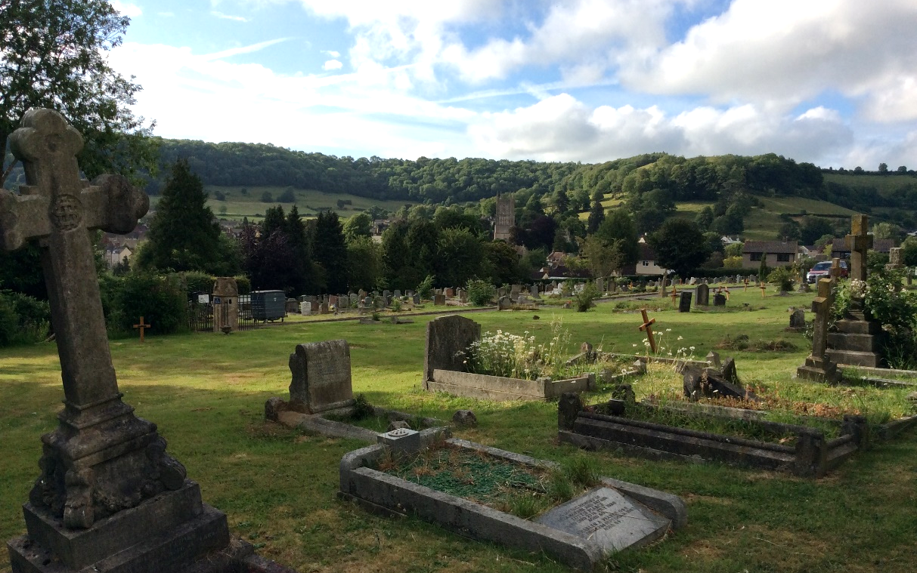

Cemetery Regulations
& Management Plan
Wotton-under-Edge Town Council
Updated May 2019

Table of Contents
Part 1 General | - General interpretation | Page 3
 | - Application of regulations | 3
 | - Administration | 3
 | - Opening hours & Access | 4
 | - Fees and charges | 4
 | - Site maintenance | 4
Part 2 Burials | - Exclusive right of burial | 4
 | - Grave selection | 5
 | - Transfer of exclusive right of burial | 5
 | - Death of grant holder | 5
 | - Surrendering exclusive right of burial | 5
Part 3 Interment | - Notice of interment | 5
 | - Council authorisation | 6
 | - Grave location | 6
 | - Proof of exclusive right of burial | 6
 | - Coffin & grave dimensions | 6
 | - Burial Register/Certificates | 7
 | - Burial service & bearing of coffin | 7
Part 4 Cremation | - Burial of cremated remains | 8
 | - Application for burial & location for cremated remains | 8
 | - Garden of Remembrance | 8
Part 5 Memorials | - Memorial applications & inscriptions | 9
 | - Memorial dimensions | 9
 | - Planting & floral tributes | 10
 | - Removal of memorials | 10
 | - Memorial construction | 11
 | - Memorial identification | 11
 | - Unsafe & neglected memorials | 11
 | - Grave maintenance | 11
 | - Loss or damage | 12
 | - Access | 12
Part 6 Conduct | - Vehicles | 12
within cemetery | - Conduct within cemetery grounds | 12
 | - Dogs | 13
 | - Approved contractors conduct within cemetery | 13
Part 7 Exhumations | - Exhumations | 13
Part 8 Reserved | - Differences or Disputes | 13
Rights of Council | - Amendments to Regulations | 13
Appendix 1 | A1. Schedule of fees/charges as at 1st April 2018 | 14
Appendix 2 | A2. Risk Assessment of Cemetery April 2018 | 15
Appendix 3 | A3. Exclusive Right of Burial Application Form | 18
Appendix 4 | A4. Memorial application form | 19

Part 1
1.General interpretation

ln these Regulations:
1.1 "Approved Contractor" means those contractors who are employed by the Council or any other third party (e.g. Funeral Director/Grant Holder) who satisfy the criteria as set by the Council from time to time.
1.2 "Exclusive Right of Burial" means subject to paragraph 7 below, a right that must be purchased from the Council which grants the purchaser, and his or her successors, the Exclusive Right of Burial in a designated burial plot for a period of 100 years.
1.3 "Grant Holder" means:
a) the owner(s) of an Exclusive Right of Burial or
b) if the Grant Holder is deceased then the appointed Executor(s) or Personal Representative(s) of the Grant Holder or the person to whom the Executor(s) or the Personal Representative(s) of the Grant Holder have assigned the Exclusive Right of Burial
c) if the Grant Holder is deceased and no Executor(s) or Personal Representative(s) has/have been appointed then the next of kin (a statutory declaration would need to be completed based on the facts in each case – ownership can’t transfer automatically to the next of kin).
1.4 "lnterment" includes:
a) a full body in a suitable container eg coffin, casket or shroud
b) the interment of cremated human remains;
c) the interment of the bodies of stiIlborn children or of the cremated remains thereof
d) the interment of the bodies of babies under 24 weeks gestation
1.5 “Memorial” means any headstone, gravestone, monument, vault, kerbstone (which shall include the expression “kerb” or “kerbing”), grave furniture, or other grave surrounds designated and shown as such on the plans maintained by the Council.
1.6 "Opening Hours" means the times during which the Cemeteries are open to the public as specified in paragraph 4.
1.7 “Supervisor” means the officer of the Council responsible for the day-to-day management of the Cemetery.
1.8 "Schedule of Fees and Charges" means the schedule maintained by the Council (available for inspection on the Council’s website www.wotton-under-edge.com or by contacting the Council Office) setting out the matters in respect of which fees or other charges are payable to the Council and the amount of each such fee or charge.
1.9 References to the masculine and to the singular shall be taken to refer to the feminine and the plural and vice versa as the case may be.
1.10 The headings are for convenience only and shall not affect the interpretation of these regulations.
1.11 References in these regulations to any statute, statutory provision or other legislation or regulations or codes of practice shall include a reference to the same as amended, extended, consolidated or replaced from time to time and include any order, regulation, instrument or other subordinate legislation made under the same.

2 Application of the Regulations
2.1 These Regulations cover Wotton Cemetery only.

3 Administration
3.1 All enquiries regarding Wotton Cemetery should be directed to the Town Clerk at Wotton-under-Edge Town Council, Civic Centre, Wotton-under-Edge GL12 7DN, tel 01453 843210.
3.2 The Council Office is open for calls in person, by telephone, or email from 9:00am to 12:30pm Monday to Friday with the exception of Public Holidays.
3.3 Plans and registers may be inspected at the Council Office by prior arrangement. Searches can be made free of charge.

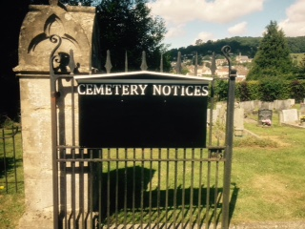
4 Opening Hours & Access

4.1 The Cemetery is open to the public every day unless otherwise indicated by notices placed in conspicuous positions at the entrances. Specified areas in the Cemetery may be temporarily closed to visitors by placing warning cones/tape in conspicuous positions identifying the areas of work. Vehicular access is very limited on site with a small turning space.

5 Fees and Charges

5.1 The Cemetery Schedule of Fees and Charges is maintained and reviewed annually by the Council. It is available for inspection on the Council’s website www.wotton-under-edge.com or contact the Council Office or refer to Appendix 1 at the end of this document.

5.2 To qualify as a resident of Wotton-under-Edge, the deceased must have lived in the town during the 3 years prior to death (or for 3 years prior if the deceased moved to a nursing home). In all other cases, the fees, payments and sums will be equivalent to the resident’s fee times two. (Proof of residency may be required).

5.3 Where retrospective requests for Exclusive Right of Burial and/or memorials are made at least one person so interred must qualify as a resident of Wotton-under-Edge to attract the lower fee. (Proof of residency may be required).

6 Site Maintenance

6.1 General grass cutting/site maintenance will be carried out by the Council and various contractors within the burial grounds at a frequency determined by weather conditions and by the working schedules of the Council. Maintenance may differ from the normal grass cutting cycle in any areas identified by Council as conservation/ wildlife zones and along with improvement plans for the site.

Part 2
7. Exclusive Right of Burial

7.1 Wotton-under-Edge Town Council only allows interments in graves after the purchase of an Exclusive Right of Burial, which is also essential prior to installing a memorial on a grave. An application to purchase an Exclusive Right of Burial, which is granted for a period of 50 years is made by applying directly to Wotton-under-Edge Town Council. This is now done at the same time as applying for an interment since burial plots are no longer sold in advance. A Deed of Grant detailing the Plot Number is issued to the Applicant from the Council as proof of their ownership of the Exclusive Right of Burial, and they will have their details entered into a Register which is maintained for this purpose by the Council.

7.2 An interment form must be completed by the Applicant for every burial within the Cemetery (Appendix A3 to this document). For the purposes of any such application, prior to the interment, the applicant shall:
a) deliver to the Council office such documents and other information in writing as may be required; and
b) pay the prescribed fee as set out in the Schedule of Fees and Charges.

7.3 It is the responsibility of the Grant Holder to notify the Council of any subsequent change of name or address.

7.4 At the expiration of the 50 year period of the Exclusive Right of Burial, the purchaser, or Grant Holder, will have the option of renewing the Right, subject to such restrictions and regulations as may be in force at the time and on payment of the appropriate fee. Application should be made for renewal of the Right within 12 months of the expiry of the previous Grant. If no application to renew has been received the Council may grant a renewed Right of Burial to another person, but before doing so will, where possible, notify the previous Grant Holder and give the option of renewal.

8 Grave selection
8.1 When applying for an Exclusive Right of Burial, responsibility for selecting the location of the burial plot rests with the Council. The Council shall endeavour to meet the wishes of the applicant provided it is practicable to do so.

9 Transfer of an Exclusive Right of Burial

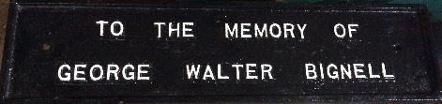
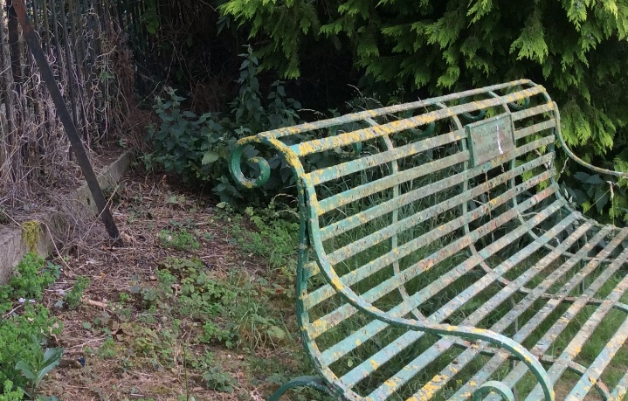
9.1 Subject to the written approval of the Council, a living Grant Holder may assign (transfer) his Exclusive Right of Burial subject to the Grant Holder completing and giving to the Council a signed letter notifying the Council of the assignment.

9.2 Upon receipt of the assignment letter, the Council will, if it approves the assignment:
a. provide written confirmation of the assignment to both the assignor and the assignee; and
b. update the Council register containing details of grave ownership.

10 Death of Grant Holder

10.1 When a Grant Holder dies the Exclusive Right of Burial may be assigned to any Executor(s) or Personal Representative(s) by submitting to the Council the Grant of Probate or the Grant of Letters of Administration until such time as the Exclusive Right of Burial is assigned by the Executor(s) or the Personal Representative(s) to any beneficiary.

10.2 lf a Grant Holder dies without bequeathing his Exclusive Right to Burial in his will or dies intestate it may be assigned to the name of the next of kin by submitting to the Council:
a) the Grant of Probate and a completed Form of Assignment signed by the Executor(s) named in the Grant of Probate: or
b) the Grant of Letters of Administration and a completed Form of Assignment signed by the Personal Representative(s) named in the Grant of Letters of Administration; or
c) where no Grant of Probate or Grant of Letters of Administration has been obtained, a Statutory Declaration by the next of kin .

11 Surrendering an Existing Exclusive Right of Burial

11.1 Where no interment has taken place in the grave space, the owner of any pre-purchased Exclusive Right of Burial may surrender the same to the Council. No refund is made by the Council for unused, pre-purchased burial plots.

Part 3
12 Notice of Interment

12.1 Three working days written notice of a proposed burial must be given to the Council by completing a Notice of Interment form (obtainable from the Council Office or Appendix A3 ) as early as possible. Responsibility for any error therein will rest with the person signing the prescribed form. Failure to submit the written notice within the agreed time will act as a cancellation of any verbal arrangements previously agreed and the burial will not be allowed to proceed.

12.2 The three working days notice, as stated in paragraph 13.1 may, at the discretion of the Council, be reduced on request in order to comply with the customary or religious practice of any community group.

12.3 All interments must take place between:
a) 9am – 3:00pm from 1st November to 31st March inclusive Monday-Fridays
b) 9am – 4:00pm from 1st April to 31st October inclusive Monday-Fridays
There is no facility for interments on Saturdays or Sundays.

12.4 Interments outside the hours stated in 13.3 will only be permitted if a certificate can be produced from a Coroner or registered medical practitioner stating that immediate interment is necessary.

13 Council authorisation for burial

13.1 Upon receipt of a completed Notice of Interment, the Council will authorise the proposed burial. Any publicity or pre-announced arrangements for burial, before Council’s authorisation, are the responsibility of the undertaker.

14 Grave location

14.1 Plans showing the grave spaces are kept by the Council and may be viewed during Council office opening hours. New graves will be allocated in strict rotation within each section of the cemetery.

14.2 Unless the deceased is to be interred pursuant to a previously purchased Exclusive Right of Burial, the Council shall specify the grave location. The Council also reserves the right to offer an alternative site to an existing Exclusive Right of Burial should the ground conditions prove unsuitable and unsafe for grave digging in accordance with current Health and Safety requirements.

14.3 Grave spaces will be marked with an identification marker by the Council prior to grave digging.

15. Proof of Exclusive Right of Burial

15.1 If the deceased is to be interred pursuant to an Exclusive Right of Burial, the Grant Holder must establish their identity and, if different, the identity of the deceased, to the satisfaction of the Council as the Grant Holder of that Exclusive Right of Burial, before the interment can take place.

16 Coffin & Grave Dimensions

16.1 The exact size of the coffin, casket or container, including handles, must be given in writing to the Council Office as soon as possible and no later than three working days before the interment, via the interment Form, unless 12.2 applies.

16.2 All graves will be prepared by persons employed by the Funeral Director who satisfy the criteria as set by the Council and detailed in the ‘Approved Contractors Conduct within Cemetery’ section.

16.3 No body shall be buried in a grave in such a manner that any part of the coffin is less than 3 feet below the level of any ground adjoining the grave. The Council may, where they consider the soil to be of a suitable character, permit a coffin to be placed not less than 2 feet below the level of any ground adjoining the grave.

16.4 No body shall be buried in a grave unless the coffin is effectively separated from any coffin interred in the grave on a previous occasion by means of a layer of earth not less than 6 inches thick.

16.5 Where any grave is reopened for the purposes of making another burial therein no person shall disturb any human remains interred therein or remove therefrom any soil which is offensive.

16.6 If a ‘shallow grave’ is encountered at the time of reopening for a further interment the Institute of Cemetery and Crematorium Management Policy relating to Shallow Depth Graves must be followed.

16.7 To ensure Health and Safety requirements are complied with, the Council in consultation with the Funeral Director/gravedigger, reserves the right to determine the maximum depth of a grave depending upon soil conditions.

17 Burial Register/Certificates

17.1 The relevant certificate(s) for the interment of the body issued by the Registrar and/or Coroner shall be produced to an officer of the Council prior to interment. Failure to produce the relevant certificate(s) will result in the interment being delayed until such certificate(s) is/are produced.

17.2 If the death has been registered but the certificate of disposal has not been brought to the cemetery prior to the funeral, the burial may not proceed. The certificate for burial (commonly called ‘the green form’) must be presented to the Council prior to burial taking place.

17.3 The Medical Practitioner’s or Midwife’s certificate of delivery will be required for the interment of a baby of less than 24 weeks gestation.

18 Burial service & Bearing of coffin

18.1 The person or persons arranging the interment shall be responsible for the attendance of a Minster of Religion, celebrant or other person to officiate the burial service (if one is required) and for payment of any fee to which the minister is entitled.

18.2 Any form of appropriate religious service may be used, or alternatively the coffin/casket maybe committed without a service.

18.3 The Funeral Director is responsible for:
a) conducting the coffin to the grave in accordance with standards of safe practice and orderliness acceptable to the Council; and
b) providing sufficient bearers to lower the coffin in accordance with safe working practices.

18.4 Each body brought into the cemetery for interment shall be contained in a suitable bio-degradable container, coffin or shroud. No container, coffin or shroud shall be accepted unless it bears adequate particulars of the identity of the deceased person therein.

18.5 After an interment, the site must be well tamped down, mounded to approximately 30cm to allow for sinkage and covered with the displaced turves. The area must be left clean and tidy. Any unwanted spoil must be removed from the Cemetery and under no circumstance be left within the curtilage of the cemetery without the express permission of the Town Council. Kerbstones or borderstones are no longer permitted. However, the Town Council will allow graves to be edged in wood 1 inch thick at ground level (not protruding above grass) provided the necessary permission has been given. Any other materials will not be permitted and the Town Council reserve the right to remove any such materials

Part 4
19 Burial of Cremated remains

19.1 Cremated remains may be interred in an existing grave, either in a suitable bio-degradable container or by pouring, with permission of the Council and in accordance with grave space available, up to a maximum of 3 per grave plot.
19.2 Cremated remains may not be scattered in any part of the cemetery.
19.3 Cremated remains may be interred in the Garden of Remembrance which are designated plots for cremated remains only.

20 Application for Burial & Location of cremated remains

20.1 UnIess the deceased is to be interred pursuant to an existing Exclusive Right of Burial, the Council shall specify the burial location for cremated remains.
20.2 A Notice of Interment for the burial of cremated remains in a grave space or Garden of Remembrance must be made in the same manner and providing the same information as in part 3.

21 Garden of Remembrance

21.1 In the case of the Garden of Remembrance at Wotton Cemetery, records are kept of the exact location of cremated remains. The choice of location where cremated remains are to be interred will be at the discretion of the Council and is usually undertaken by rotation to next available space. It is not possible to reserve plots.

21.2 Urns or casket size in the Garden of Remembrance at Wotton Cemetery must fit easily within the 30cm square space allowed.

21.3 Memorial plaques must be installed by a certified stonemason and must be no larger than 30cm square and 10cm high. Application for plaques detailing inscriptions must be made in advance to the Council for approval. A monochrome photographic image of the deceased may be laser etched onto the plaque, however the layout and a copy of the image must be approved by the Council. Any other design of plaque must receive approval and may be subject to an additional fee. Inscribed brass plaques are not permitted.

21.4 No planting is allowed in the Garden of Remembrance.

21.5 Floral tributes placed will be removed 3 months after the interment of cremated remains if not previously claimed by relatives. The placing of multi flower vases or other memorabilia is prohibited. One stone vase or flower receptacle only is allowed on each Memorial plaque, and this may be either built into plaque itself or placed on top (maximum height & width 160mm). No other ornamentation is permitted on top of the plaque or surrounding it. Dead or unsightly flowers/displays will be removed when necessary. Plastic flowers will be removed after 12 weeks. Placement of any object in the Garden of Remembrance which contravenes these regulations will be moved to the rear of Garden to be collected by owner within 12 weeks, or disposed of thereafter.

Part 5
22 Memorials

22 Memorial applications & Inscriptions
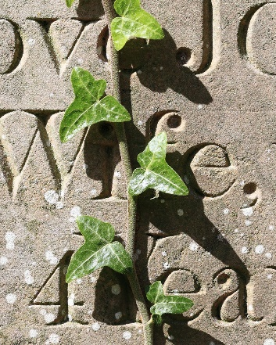
a) The Grant Holder, or stonemason acting on their behalf, must apply to the Council, and receive written authorisation from the Council, before any Memorial is erected in the Cemetery, or any inscription is placed on any Memorial in the Cemetery

b) Any Memorial or any inscription so authorised will be erected or placed entirely in accordance with the terms and conditions of that authorisation.

c) A monochrome photographic image of the deceased may be laser etched directly onto the headstone, however the layout and a copy of the image must be approved by the Town Council.

d) If any Memorial is erected or any inscription placed on a Memorial other than in strict accordance with the terms and conditions of the written authorisation from the Council, the Grant Holder shall on being so required in writing by the Council carry out any work required by the Council to ensure compliance with the terms and conditions of the written authorisation, any such work to be at the entire expense of the Grant Holder and to be carried out to the complete satisfaction of the Council.

e) In the event that the Grant Holder fails to comply with any such written requirements within a period of time satisfactory to the Council, the Council shall be entitled, at the expense of the Grant Holder, on giving not less than 21 days notice in writing to the Grant Holder, to secure the removal of any such Memorial or to secure the removal of any such inscription.

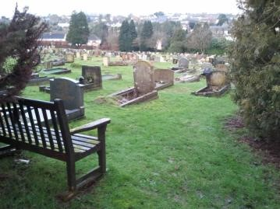
f) Any Memorial that has been removed in accordance with the provisions of paragraph 23 d) above will be kept at Council premises for 60 days from and including the date of the removal, for collection by or on behalf of the Grant Holder. If the Memorial is not collected within this period it will be disposed of by the Council.

g) In the event of disposal in the circumstances specified in paragraph 23 e) above the Grant Holder will not be entitled to any recompense.

h) Council will attempt to contact the Grant Holder before action is taken but cannot be held responsible if prior contact is not or cannot be made.

23 Memorial dimensions

23.1 Memorials must not exceed the following maximum dimensions:
a) Headstones including base (with or without vase) are not to exceed 100cm in height, 75cm wide, and 50cm length, and must exceed 60cm height
b) Tablet must not exceed the headstone dimensions specified above.
c) Memorial vase must not exceed 30cm in height.
e) Simple Wooden Cross pending the erection of a permanent memorial must not exceed 100cm in height and must not be less than 60cm in height.

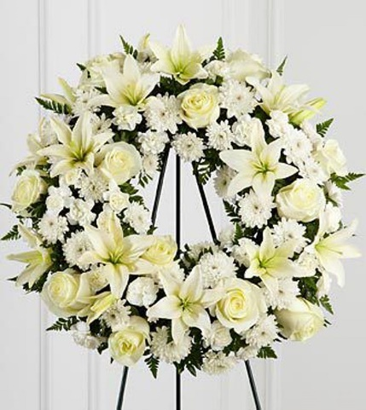
24 Planting & Floral Tributes

24.1 Other than in cases of historical precedence, permanent planting is restricted to the area immediately in front of the headstone/head of the grave and shall not exceed 75cm length and 60cm width measured from the back of the headstone/head of the grave. The remainder of the grave space must be left level and grassed, in order that access to adjoining plots and maintenance are neither compromised nor inconvenienced.

24.2 Small annual bedding plants or bulbs may be planted on a grave in the area specified above in 24.1, as directed by the Council, but the planting of shrubs and trees is not permitted.

24.3 Council reserves the right, without notice, to eliminate the mound over any grave or otherwise to deal with such a grave space if, in its opinion it is untidy and/or could pose a risk to others. The placing of flower vases or other permanent receptacles on graves which can be mown over is prohibited.

24.4 Following an interment, all funeral wreaths and floral tributes will be left on a grave by the Council for a period of not less than 4 weeks. After the 4 week period has lapsed, wreaths and flowers will be removed if this has not already been done so and included in the regular grass cutting schedule. It is the responsibility of the Grant Holder to keep the grave space free from weeds and in a tidy condition. The Council reserves the right to level and turf/reseed the grave.

24.5 The erection of a Memorial or the placing of an inscription will be permitted only where:
a) an Exclusive Right of Burial exists;
b) evidence of the identity of the Grant holder is produced to the Council
c) an application signed by the Grant Holder is received by the Council
d) payment of the prescribed fee as specified in the Schedule of Fees and Charges has been made to the Council;
e) the written authorisation of the Council has been granted;

24.6 Any works to memorials shall not take place until 12 months from the date of interment to allow for settlement of the grave space (this may be waived in the case of interment of ashes, but authorisation of Council must be granted). The Council will not normally object to the marking of a grave by a simple wooden cross pending the erection of a permanent memorial, but reserves the right to remove any such grave marker. Approval for a memorial may be sought at any time in that year, but fees must be paid in full at the time of the permission, not the installation.
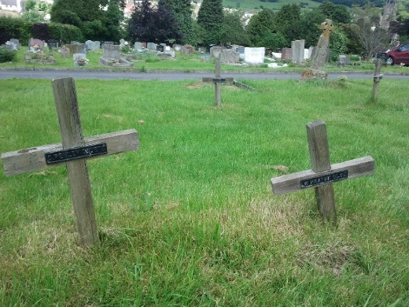
24.7 The Council will permit a simple wooden cross to initially mark a grave. Subsequent crosses must conform to headstone regulations.

24.8 The Council reserve the right to remove any unsafe wooden crosses without prior notice to the grave owner, to maintain the safety of staff and visitors in the cemetery.

24.9 All Memorials and headstones, including the re-fixing and refurbishment of Memorials, must be fitted by BRAMM (or equivalent body) approved stonemason.

25 Removal of Memorials

25.1 No Memorial, or part of a Memorial, shall be removed from a grave without the written approval of the Council.

25.2 The Council’s approval of a proposed burial shall be considered consent to remove temporarily any Memorial from the grave to be re-opened.

25.3 The Grant Holder is responsible for the removal and re-fixing of a Memorial in connection with a burial and may only use BRAMM (or equivalent body) approved stonemasons for this purpose.

26 Memorial construction

26.1 All Memorials must be able to bear continuous exposure to the weather and must be made of durable natural stone. Teak and similar hardwoods may be permitted for a permanent cross but the Council reserves the right to remove the memorial when its condition has, in the opinion of the Council, deteriorated below that which is acceptable.

27 Memorial identification

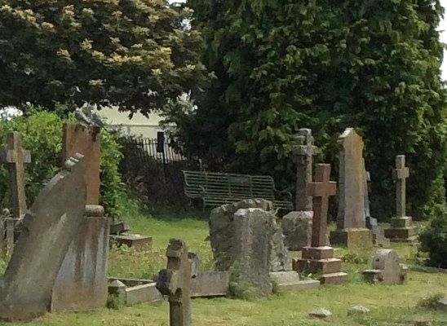
27.1 The grave number must be clearly but discreetly inscribed on the back of the Memorial. The name of the memorial contractor shall not appear anywhere on the memorial.

28 Unsafe and neglected Memorials

28.1 The Grant Holder shall maintain their Memorial in a safe condition and to the complete satisfaction of the Council. The Council reserves the right periodically to inspect and test Memorials for stability.

28.2 Subject to paragraph 29.3 below where the Council, in its absolute discretion, considers a Memorial to be unsafe or likely to become unsafe it shall, in order to protect public safety, notify any relevant Grant Holder in writing and give the Grant Holder a reasonable opportunity to make the Memorial safe to the complete satisfaction of the Council.

28.3 If the Council, in its absolute discretion considers it appropriate or necessary it shall, at the expense of the Grant Holder, take immediate action and carry out such work as is necessary to restore the Memorial to a safe condition in order to protect public safety e.g. lay the memorial down.

28.4 If the Grant Holder does not comply with the requirements of the Council under paragraph 29.2 above within the period the Council considers to be reasonable, or cannot be contacted, the Council shall be entitled, at the expense of the Grant Holder to take such action and carry out such work as is necessary to restore the Memorial to a safe condition or remove the memorial completely, in order to protect public safety.

28.5 In instances whereby it is not possible to trace the Grant Holder or complete an associated Transfer of the Exclusive Right of Burial for the affected grave space, the Council may allow the reinstatement of a memorial to a safe condition by another. If such work is permitted this would be carried out on the understanding that if the Grant Holder or somebody with a stronger claim to the Exclusive Right of Burial contacted the Council and objected, the work would be undone.

29 Grave maintenance

29.1 The Council provides no service for the maintenance of graves and reserves the right to determine and to give directions as to how the Cemetery and any grave therein shall be governed and/or maintained.

29.2 If any of the following has not been previously authorised by the Council, the Council reserves the right without notice to clear and re-instate any grave following the:
a) planting of any gardens, trees or shrubs;
b) placing of any grave furniture;
c) placing of unauthorised vases, containers, tins, plates, pots, candle holders, jars and ornaments made of breakable material (e.g. glass or porcelain) and memento articles such as wind chimes, flags, banners, toys, decorations hung on metal stakes stuck into the ground etc.;
d) placing of any unauthorised decorative fencing, edging, surrounds and chippings.

30 Loss or damage

30.1 Memorials are placed at the Grant HoIder's own risk. The Council is not responsible for loss or damage done to any grave space or Memorial or injury to any person within the Cemetery, except where such damage is directly attributable to the negligence of the Council or its employees. Grant Holders are accordingly advised to obtain adequate insurance cover (public liability, accidental damage arising from storms, vandalism and any other damage), for their Memorials.

31 Access

31.1 All works in connection with the erection or restoration of Memorials must be carried out at times to be agreed with the Council.

Part 6 Conduct within the cemetery
32 Vehicles
32.1 Vehicles are not permitted in the Cemetery unless authorised by the Council or tending to a grave.
32.2 Any such authorised vehicles, including bicycles, entering the Cemetery must be driven with due care and attention, comply with all directional signs, comply with any Council employees’ directions, and not be taken onto grassed areas without Council permission.
32.3 The Council shall not be held responsible for any injury caused by a public vehicle, damage to vehicles or other property left within the Cemetery.

33 General Conduct within Cemetery grounds

33.1 No person while in the Cemetery grounds shall:
a) wilfully create any disturbance;
b) commit any nuisance;
c) wilfully interfere with any burial taking place;
d) wilfully interfere with any grave, Memorial, or any flowers or plants; or
e) play at any game or sport

33.2 The Council, in its absolute discretion, reserves the right to ask any person to leave a Cemetery.
33.3 Smoking is prohibited in the Cemetery near any place where a funeral or religious service is being performed.

33.4 Extraordinary Processions. No extraordinary funeral procession will be permitted to enter the Cemetery except by permission of the Council (whose decision as to whether or not a procession is “extraordinary” shall be final). The Council may exclude from the Cemetery or any section thereof, any person or persons not being mourners or officially connected with such funeral. Parties having charge of a military funeral or funeral procession connected with societies or public bodies are required to make such arrangements with the Council to ensure the protection of the Cemetery from damage.

33.5 No band or music will be allowed to play in the Cemetery save at a military funeral or by prior consent from the Council.

34 Dogs
34.1 Dogs’ owners shall ensure:
a) their dog is kept on a lead and restrained from straying off paths and drives;
b) their dog does not interfere with, or disturb, any other person in the Cemetery; and
c) all faeces excreted by their dog is removed from the cemetery in an appropriate manner. Failure to do so may lead to prosecution under the Dog (Fouling of Land) Act 1996.

35 Approved Contractors' conduct within Cemetery

35.1 Approved Contractors will notify the Council in advance of their intention to work in the Cemetery and will not commence work until they are in receipt of the written authorisation of the Council. Contractors must pay attention to Council correspondence regarding burials taking place.

35.2 Approved Contractors will make available copies of insurance, health and safety risk assessments and method statements when required. Work should be carried out with due regard to the Code of Safe Working Practice for Cemeteries issued by the Institute of Cemetery and Crematorium Management, taking into account risk assessments made by the user in respect of local conditions, soil type, customs etc.

35.3 While carrying out work within the Cemetery, all Approved Contractors shall ensure that they:
a) take all necessary precautions and comply with any requests from the Council to protect the grass, trees, plants, walls, paths and any Memorials from damage. Any damage caused shall be made good entirely at the Approved Contractor’s expense; and to the complete satisfaction of the Council.
b) completely remove all waste, unwanted materials and tools from the Cemetery when work has stopped. If material/rubbish is left in the Cemetery following the work the Council will arrange for the removal of it from the site and will reserve the right to charge the contractor accordingly.

Part 7
Exhumations
36 After interment no body or cremated remains may be removed from a grave before the production of the necessary ecclesiastical Faculty or Ministry of Justice licence required by law. The Council will require the original documents for this purpose. Fees for exhumation will be determined on an individual basis.

Part 8
Reserved Rights of the Managing Authority
37 Differences or disputes
Should any difference or dispute arise as to the real intent, meaning or interpretation of these Regulations, or Schedule of Fees and Charges, the decision of an authorised officer as the designated representative of the Council shall be final.

38 Amendment of Regulations
The Council reserves the right to alter these Regulations or any part of them from time to time as it may see fit.

Cemeteries under the control of Wotton-under-Edge Town Council are managed and operated in accordance with the Local Authorities' Cemeteries Order 1977, as amended by the Local Authorities’ (Amendment) Order 1986 and such other regulations as may be made by the Secretary of State for the Home Office.
****************

Appendix 1 Schedule of fees and Charges

Wotton-under-Edge Town Council
BURIAL CHARGES
CEMETERY CHARGES & BURIAL REGULATIONS
The November 2016 meeting of Town Council agreed to abolish fees for burials of a child under 5 years old, and reduce by 50% fees for children between 5 and 16 years of age, applicable to residents of Wotton. The fees and charges set out below apply where the person to be interred, or the person in respect of whom a right is granted, is or was an inhabitant or parishioner of Wotton-under-Edge or, in the case of a stillborn child, where the parents (or one of them) are, or at the time of the interment were such inhabitants or parishioners. In all other cases the fees and charges will be doubled.

BURIAL CHARGES FROM 1ST APRIL 2022

 |  | From 1st April 2022
A | Any interment in an earthen grave | £200
B | Interment of cremated remains in an earthen grave | £140
C | The purchase of a plot for the exclusive Right of Burial in an earthen plot for 50 years. 50% reduction for Wotton resident children 5 to 16 ages, free for ages 0 to 5. | £380
D | Interment of baby/child up to 16 years old. Wotton resident 0 to 5 years old free, 50% reduction ages 5 to 16.
E | The Right to Erect Gravestones, Monuments & Inscriptions  - A headstone with plinth or base not exceeding 3/4 metre wide by 1/2 metre length and not exceeding 1 metre in height. Other sizes of memorials - price on application  - A headstone with or without plinth in baby section (and usually a smaller sized headstone)  - Inscribed vase  - Flat stone  - Wooden Cross  - The fees listed include the right of the first inscription. Further inscriptions on existing headstones | £200  £100  £80  £100  £95  £95
F | GARDEN OF REMEMBRANCE | £360

Appendix 2 to be inserted at later date

A3 Exclusive Right of Burial /Interment Form

Wotton-under-Edge Town Council

NOTICE OF INTERMENT WOTTON-UNDER-EDGE BURIAL AUTHORITY

1. Full name of person to be interred ………………………………………………………………………………….

2. Profession of Person to be interred or,
if a minor, name and address of parents ………………………………………………………………………………….

3. Age of Person to be buried ………………………………………………………………………………….

4. Date of Death ………………………………………………………………………………….

5. Place where death occurred ………………………………………………………………………………….

6. Usual place of residence ………………………………………………………………………………….

7. Day and date of burial ………………………………………………………………………………….

8. Time of arrival at Wotton-under-Edge
Cemetery …………………………………………………………………………………

9. Name of Minister officiating (if any) …………………………………………………………………………………

10. Marks of intended grave space
(number and/or identification) …………………………………………………………………………………

11. Whether in Grave or Garden of
Remembrance plot …………………………………………………………………….............

12. Whether the exclusive right of burial
has been purchased, and who is now the
owner of such right. (name & address)
…………………………………………………………………….………...

13. Proposed depth of grave …………………………………………………………………….…………

14. Exact size of coffin ……………………………………………………………………………….

Signature of applicant. Please also give
name and contact details if different from
those in section 12 above.
…………………………………………………………………….………..

Date …………………………………………………………………….………..

Appendix A4
Wotton-under-Edge Town Council
APPLICATION FORM TO INTRODUCE A MEMORIAL INTO WOTTON-UNDER-EDGE CEMETERY
The Town Council will accept other form layouts from undertakers, with the following amount of information as a minimum
Name of Deceased ………………………………………………………………….
Name & Address of Applicant ………………………………………………………………….
………………………………………………………………….
………………………………………………………………….
………………………………………………………………….
………………………………………………………………….
Relationship to the Deceased ………………………………………………………………….
Proof of Ownership of Grave is required
Headstone – new headstone or additional inscription? ………………………………………………………………….
Details of Proposal (type of memorial, lettering, etc) ………………………………………………………………….
Name of Craftsman/Monumental Mason/Undertaker ………………………………………………………………….
Anticipated Installation date ………………………………………………………………….
Inscription

__________________________________________________________________________________
Office Use Only
Permission Granted By: Date:

of Wotton-under-edge Town Council Fee for this work: £
Cheques to be made payable to Wotton-under Edge Town Council and posted to the Civic Centre,
2 Gloucester St, Wotton-under-Edge, GL12 7DN, Gloucestershire.

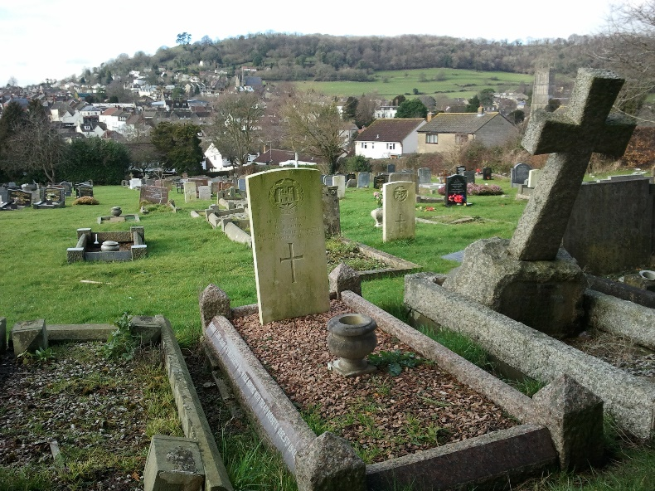

www.wotton-under-edge.com
clerk@wotton-under-edge.com
01453 843210

