Minutes of Wotton-under-Edge Town Council Extraordinary Meeting

held on Wednesday 28th September 2022 at 7.00pm in the Civic Centre

Present: Cllrs M Tucker, T Creese, R Claydon, J Lewis, J Turner, S Hunt, P Barton,

T Luker, D Thomas, T Young, L Taylor

In attendance: County Cllr L Cohen, District Cllr C Braun; A Durn (Town Clerk).

T.6667 To receive apologies for absence
Apologies were received and accepted for Cllrs N Pinnegar and J Cordwell, and District Cllrs K Tucker and G James.

T.6668 To receive Declarations of Interest and requests for Dispensations
Cllr J Turner – Payments

T.6669 To approve the Minutes of the Extraordinary meeting of the Town Council on 31st August 2022
Minute T. 6663b should read Colburn Homes.
It was RESOLVED to approve the Minutes of the Extraordinary Town Council meeting held on 31st August 2022 with the amendment as a true and fair record.

T.6670 Public Forum

Members of the public can make representations, raise questions, or submit comments
None made.

T.6671 To receive reports from County Councillor and District Councillors

County Cllr L Cohen presented the following report:
- Highways / Paths
Lengthsman month
After consultation with residents and in partnership with the Town Clerk and Councillor Teresa Crease I have conducted a complete audit of all highways and paths issues. The output from this piece of work is a detailed action plan which divides responsibility between the Town Council, Highways and the Lengthsman initiative in November. I would hope that in the next couple of months we should clear most of the back log leaving us with a small number of longer-term projects, with realistic timescales for completion.
A reminder that residents can report any issue related to potholes; lights, signals and signs; damage to pavement or kerb; road markings and stud issues trees, hedges and vegetation; drainage and flooding; spillages or obstructions on the road; Winter Maintenance - Grit and PROW - public footpaths & bridleways (not pavements). Issues can also be logged here:
https://www.gloucestershire.gov.uk/highways/roads/your-highways-report-it/
- Buses
I am meeting with Cllr Philip Robinson the Cabinet Member for bus transport in October for a drive around the area to highlight the issues and to secure backing for a new community bus project.
- Dentistry
I am speaking on a motion at the next County Council meeting to address the need to make NHS dentistry available to those who need the service. There are currently no NHS practices accepting new patients in the county. I am also pushing for routine checks to take place in schools and care homes. I would welcome input from the Town Council and any residents who would like to inform the discussion.
- Chimneys and national ‘Fire Kills’ campaign
Gloucestershire Fire and Rescue Service (GFRS) is urging residents to get their chimneys swept by an approved sweep to prevent chimney damage and household fires.
As part of the National Fire Kills campaign and prior to the colder Autumn and Winter weather, Gloucestershire Fire and Rescue Service is warning residents and landlords of the dangers of an un-swept chimney following 91 calls to a chimney fire last year and over 500 chimney fires in the last five years.
GFRS is urging local people to regularly have their chimney swept to avoid the serious damage that can be caused to homes and families.
Poorly maintained chimneys or flues can fill with debris such as cobwebs, leaves and bird’s nests along with soot or oil deposits.
Here are GFRS’s top tips:
- Sweep your chimney twice a year.
- Don’t use your fire as a rubbish bin.
- Use a fireguard.
- Keep flammable materials and furniture at least 2m from the fire.
- Use well seasoned wood.
- Make sure embers are under control and extinguished before you go to bed.
- Have at least one smoke alarm on every floor of your home and test them monthly.
How often?
Chimneys should be swept according to the type of fuel being used:
- Smokeless fuels – at least once a year
- Bituminous Coal – at least twice a year
- Wood – quarterly when in use
- Oil – at least once a year
- Gas – at least once a year (refer to gas safe register)
GFRS advises if you light your fire regularly during the winter months, then you should consider having your chimney swept more often.
It is also important to be aware of carbon monoxide poisoning symptoms that can be caused by blocked chimneys. Carbon monoxide gas is highly poisonous and can incapacitate or even kill people in a closed room within a short time.
As well as ensuring your chimney is kept clear, it is important to make sure that wood, coal or biomass fires are installed by approved engineers. They will make sure that both the fire itself and where it is installed are safe.
A faulty installation can result in fires, even invalidating home insurance in some cases.
The service encourages residents to check with HETAS, a national, independent body approved by the government.
They have registers of approved installers and chimney sweeps on their website at www.hetas.co.uk, so residents can be sure that their engineer is accredited.

My contact details linda.cohen@gloucestershire.gov.uk . Mobile 07791110906

District Cllr C Braun presented the following report:
All Stroud District Council and Committee papers can be found here: https://www.stroud.gov.uk/council-and-democracy/meetings Recordings of meetings are available via the Committee meeting webpage on the Council’s You Tube channel: https://www.youtube.com/channel/UCeH_AmF0s-TShcYlM8Stweg/videos
Council
- There have been no formal committee nor Full Council meetings in August, although your Councillors have continued to attend Task & Finish Group, various Advisory Board and administration meetings etc, along with the usual Parish and Town Council meetings.
- Following the recent changes to political Group memberships as described last month, the Lib Dems, Greens, Labour and Community Independent Parties continue to work collaboratively to deliver the Council Plan.
- The recently appointed new Monitoring Officer – Claire Hughes, has confirmed that she will join us on the 26th September. Claire attended Full Council in July and introduced herself to us and is very much looking forward to joining SDC.
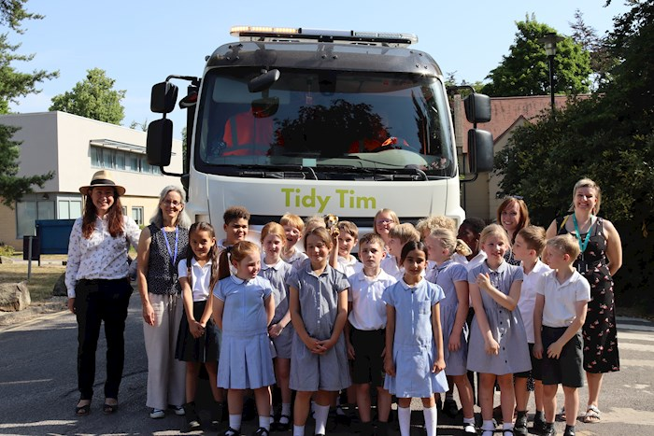
- UBICO, the Council’s refuse contractor, in which SDC is a shareholder, has received their first electric road sweeper. The Council already has eight Council owned Electric Vehicles and five Hybrids in their fleet. Following suggestions from local school children, the new sweeper has been named ‘Tidy Tim’.

Local (and other)
- Commercial planning applications.
Councillors may have read about resident’s concerns and campaigns regarding the announced opening of a Starbuck’s coffee establishment in the Five Valleys Shopping Centre in Stroud. They consider that there is already an adequate number of ‘coffee houses’ in the area. However, recent changes to planning rules, allow flexible movement between a number of different uses, such as shops, financial/professional services, restaurants and cafes, health centres, offices and light industrial uses amongst others, without the need to apply for planning permission for a change of use.
Therefore, this change of use is lawful within Class E of the Use Classes Order 1987. Class E was introduced by Government on 1st September 2020 and planning permission is therefore not needed. Current applications for this site are for physical works to the exterior of the building (S.22/1697/FUL) and new advertisements (S.22/1698/ADV) only. The council will not be able to consider the use of Unit 1 when determining these applications.
- Gloucestershire Sight Loss Council visit to Wotton under Edge.
August saw Community leaders experiencing what life is like for people with visual impairments, when they went on a town centre tour with a difference. Representatives from Stroud District Council, along with District Councillors and members of Wotton-under-Edge Town Council, joined Gloucestershire Sight Loss Council on a tour of Wotton-under-Edge town centre, wearing simulation glasses.
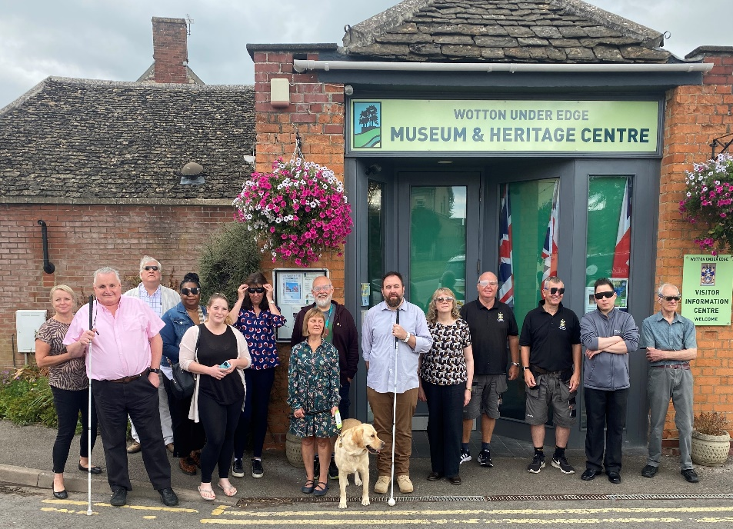

Gloucestershire Sight Loss Council is led by blind and partially sighted members. Together, they tackle local issues and work with businesses and service providers to improve the accessibility of their services. ‘Problems’ navigating our local streets were noted and where possible, will be acted on.

- Gloucester Street/Bradley Street regeneration.
Following a fire at the unoccupied SDC property at 8 Gloucester Street, the building, along with the adjoining property, where immediately made safe by contractors. More recently, the site has been wholly fenced off and some initial ground works carried out. The demolition plans are now being readied and work is expected in October. Neighbours are being regularly updated.
- UK Shared Prosperity Fund.
Councils and local groups that applied for grants from the Government’s UK Shared Prosperity Fund, were informed on the 19th August whether their application had made the short list or not. The applications for funding, which was oversubscribed 3 times, were reviewed by SDC officers against definitive and strict criteria.
Those that were successful should know whether their project will receive UKSPF funding by late Autumn. Your DCs understand that Wotton area projects have a ‘fair share’ of the proposals put forward for funding from the £1.4m budget allocated to the Stroud district.

T.6672 Chairman’s Announcements
The Chairman had circulated the following report:
AUGUST
15th Town Council meeting.
17th meeting with the youth services provider to confirm the contract would not be extended and their contract would stop on the 9th September 2022.
18th meeting with the Stroud District Council (SDC) Economic Development Strategy Officer, the new Tourism Officer, the Town Clerk, and Cllr T Creese. The meeting was held with the Heritage Centre to discuss tourism opportunities for Wotton and surrounding area. There was also a discussion on the new SDC tourism app that the Heritage Centre has been trialling.
18th meeting with Councillor Linda Cohen and two Gloucestershire Highways Managers. We walked a large part of the town centre, we also walked up into Synwell, to look at the junction where the vans and cars park, to see what solutions could be found.
There has subsequently been a meeting with Councillor Linda Cohen to formulate a lengthsman programme.
18th Remembrance Parade meeting, we have agreed the start time, route, Parade Marshalls, and applied for the required road closure notices, and Churches Together are underway with their plans.
22nd Planning meeting followed by an Extraordinary Council meeting.
23rd meeting with residents of Symn Lane, notes and issues previously shared.
24th car park meeting to review where we are and what is outstanding. We also reviewed notice boards, waste bin survey, cycle rack, and proposed list of businesses to tender for a potential ev-chargers contract solution which would mean we aren’t buying or selling electricity as also discussed at Council.
25th meeting with the Priest in Charge at the vicarage. A get to know you session which was very productive.
SEPTEMBER
7th meeting with interested parties progressing Browns Piece purchase. This was a start-up meeting to discuss the possibility of purchasing the land. There were thirteen people present. There was a discussion on vision, views, and opinions. It was decided to take the proposal forward to a public meeting, mainly to gauge support for the project, and solutions to raising the money.
11th Proclamation reading: although nervous on the day it was a great privilege to read the Proclamation. Thank you to all the Councillors who were able to come along and support the event. A special thanks to the Town Clerk who rallied everyone to ensure it went so well.
13th SDC Working Together Charter. A proposed charter is nearly complete and will come to Council in coming months. The whole purpose of the charter is to enable parish and town councils to work more closely with the district council with a formal structure in place, hopefully this will help the council feel more involved and less overlooked.
18th Civic memorial service for Queen Elizabeth II. I attended the service and read a testimonial of my life as a young child and what HM The Queen meant to me.
Thank you again to all the councillors who were able to attend.
18th Pass Wide and Slow parade. The Town Clerk, Cllr T Creese and I attended this event to raise awareness for drivers about passing horses on the road, asking them to pass them wide and slow. There were eleven horses with riders, several vehicles, and some Marshalls. We paraded from Manners Farm up through town, along Bear Street, and down to the War Memorial where they presented a bouquet for the Queen’s remembrance, then back to the farm where Cllr T Creese and I presented rosettes to all the riders taking part.
Regrettably the very next day, the organiser of the event and her horse were hit on the road by a passing driver, causing injuries to the horse, and knocking her camera off her helmet.
20th Remembrance Day Parade meeting: second meeting, plans are progressing well with no issues currently arising.
21st UK Shared Prosperity Fund bid call with Stroud District Council’s Economic Development Strategy Officer. The Town Clerk, Cllr D Taylor, and I attended a call to discuss the UKSPF. The proposal is for a solar canopy to be built in year three, 2024/2025. We will get confirmation in January 2023 if the government signs off the submitted plan from SDC.
There were no questions and the report was noted.

T.6673 Accounts
- To note increase of 25p/week (£13/annum) from 1st September 2022 for cemetery waste disposal.
The increase was noted.
- To note receipt of M&G Dividend of £1508.82 for the period 1/4/22 - 30/6/22.
The receipt was noted.
- To note 3% increase in photocopier service and consumable charges with effect from 1st October 2022.
The increase was noted.
- To note the 2020/21 Annual Return and Notice
The Responsible Finance Officer brought the Council’s attention to the external report and the comment on the incorrect date of sign off. She stated that the Council needed to check the returns to ensure all is correct before signing. The Council noted the Annual Return reports, the actions to be taken, and the publication of the Notice.
- To consider request from Wotton Lions for finance for new brackets for the town Christmas trees and possible additional funding towards purchase of trees; and agree way forward.
There was a discussion and queries were raised. It was RESOLVED for the Town Clerk and the Chairman to meet with The Lions to discuss the request and to bring back to Council.
- Budget report 2022/23.
A query was raised on the allocation of plumbing costs to particular cost codes. The report was noted.

Cllr J Turner left the meeting

- To approve September accounts for payment
It was RESOLVED to approve the payments for the September accounts.

Cllr J Turner joined the meeting

T.6674 External Funding:
a) To receive an update on the UK Shared Prosperity Fund (UKSPF) bid
The report was reviewed. It was noted that the Government may change the date for response for both the UKSPF and the Levelling Up Funds. This is to be confirmed.
b) To note the funding opportunity for the Rural UK Shared Prosperity Fund
The Government had published a new funding opportunity on 3rd September 2022 Rural England Prosperity Fund: prospectus - GOV.UK (www.gov.uk). The Council is waiting for information from Stroud District Council on how to bid for this fund and publish to the local businesses and community groups.

Cllr C Braun left the meeting

T.6675 Budget Meeting Date
Due to preparation and running of the Christmas Under The Edge event on 3rd December 2022, it was RESOLVED to hold the informal budget meeting on Monday 5th December 2022.

T.6676 Option to opt out of the SAAA central external auditor appointment arrangements
It was RESOLVED to not opt out of the SAAA central external auditor appointment arrangements

T.6677 Memorials in the Cemetery
There was a discussion on the outcome and actions taken from the memorials audit. It was RESOLVED to have a site meeting at the Cemetery to see the issues before the budget discussions.

T.6678 Training for Councillors
The Council reviewed the training opportunities provided by the Gloucestershire Association of Parish and Town Councils (GAPTC). It was RESOLVED to book the following:
Being a Better Councillor Part 2 – Cllr D Thomas
Finance for Councillors – Cllr S Hunt
Climate and Biodiversity Action – Cllr D Thomas
Youth Councils & Youth Provision – Cllrs L Taylor and T Young
Councillors were encouraged to attend training and send to the Town Clerk further requests.

T.6679 Symn Lane Play Area Improvement Request
The requests for new play equipment for children were received and discussed. It was noted that a maintenance and end of life plan, and research on grant funding opportunities, would be needed for the budget discussions.

Cllr J Turner left the meeting

T.6680 Brief reports from Councillors
Cllr T Creese reported on the Road Safety for Councillors Networking event.
Cllr R Claydon reported on the Public Rights of Way Working Group review of footpaths. He reported that the Cotswold Wardens had taken over the maintenance of footpaths and would send a list to the Town Clerk.
Cllr T Luker reported that the Synwell Playing Fields Association meeting was on the same time as the Town Council meeting. He would circulate the Minutes when received.

Cllr L Cohen left the meeting

T.6681 EXEMPT ITEMS: Prior to consideration of the following agenda items, councillors are invited to pass the following resolution: Pursuant to the provisions of the Public Bodies (admissions to Meetings) Act 1960 (as extended by S100 of the Local Government Act 1972), the Press and Public be excluded from the meeting for the following items of business on the grounds that its consideration would involve the disclosure of exempt information
It was RESOLVED to exclude the Press and Public.

Cllr J Turner joined the meeting

T.6682 New Road Allotments
There was a discussion on the quotes received and that one was due on 30th September 2022.
It was RESOLVED for to delegate to the Town Clerk and Cllr P Barton to review the quotes received after 30th September 2022 and award on best value for money.
T.6683 Symn Lane Play Area
The design options and quotes were reviewed. It was RESOLVED to approve the gate to be supplied from GB Sports and for the Council staff to install. Thanks were given to Cllr J Lewis for his help and direction.
T. 6684 Youth Services Contract
Cllr T Young presented her report on the options for youth service provision and support for the next 6 months whilst the National Youth Agency carry out their contracted services. There was a lengthy discussion on the detail and flexibility of the service proposed, age of young people targeted, the length of the contract, the outcomes, value for money, and integration with the NYA review.
It was RESOLVED to award the contract to Play Gloucestershire to provide active and creative outdoor activities play for 6 months which includes after school sessions and holiday play days. Cllr T Young to work closely with Play Gloucestershire on the service provision.
It was noted that the previous Youth Service Provider had not provided a written final report at the end of their contract which had been expected.

T. 6685 Land at Durns Road
A report was given from Cllrs Claydon and Taylor on their search of the conveyance documents. They reported that there were no conditions in the conveyance apart that there could be no building works within 3m of the sewer. There was a lengthy discussion on the proposals 50 years ago to have a footpath along the stream similar to the Streamside and Marchesi footpath and the current complications of realising that proposal after that length of time. Some Councillors expressed frustration that a decision had still not been made and it was RESOLVED for a decision to be made at the next Council meeting.
T. 6686 Symn Lane Car Park
An update was given on the development of the car park and concerns raised:
- Meetings are being held with EV Charger companies
- Meeting with the Energy Saving Trust and OZEV to clarify the bid and agree on any information required
- Meeting with GHR, the developer, on the concerns and issues, the progress of the action plan and timetable.
- Meeting with Gloucestershire County Council and their contracted partner on the EV Chargers project

T. 6687 Town Hall
An update was given on sourcing the reports from the structural engineers and compliance designer that were sent to the Project Manager so that a new procurement can take place.

The meeting ended at 9.05pm

Signed: Date:

